**Lab 5:** The installation of Duo Security, Enterprise Browser Management, and Grafana

**Security Team:** Luis Ruiz, Marcos Vallejos, Ryan Rockett, Kari Hattabaugh

Table of Contents

Introduction (Luis) 2

Scope (Kari) 2

Duo Mobile 4

Information About Tool (Marcos) 4

Prerequisites (Marcos) 5

Instructions (Kari) 5

Installation 5

Configuration 8

Testing 13

Recommendations (Ryan) 16

Alternatives (Luis) 16

Enterprise Browser Management 17

Information About Tool (Marcos) 17

Prerequisites (Marcos) 18

Instructions (Ryan) 18

Installation 18

Configuration 28

Testing 31

Recommendations (Luis) 33

Alternatives (Kari) 33

Grafana 34

Information About Tool (Marcos) 34

Prerequisites (Marcos) 34

Instructions (Luis) 35

Installation 35

Configuration 45

Testing 49

Alternatives (Ryan) 52

Conclusion (Luis) 52

References 54

# Introduction (Luis)

Our security team has been tasked with providing a detailed guideline on the implementation of an integrated defense in depth strategy for Ashburn’s Frog Emporium’s informational security needs. The first tool we will install is Duo Mobile to provide Authentication and Password Security through Two Factor Authentication. We will be using Duo Mobile to authenticate users through push notifications through their mobile devices or tablets when they are accessing our applications, if the login seems suspicious, then access will be restricted.The Second tool we will be using is Enterprise Browser Management to harden our browser, which we have selected to be Google Chrome. The tools we have installed so far cannot prevent our users on our internal network from accessing untrusted or unwanted websites, so, we will harden Google Chrome (the only approved browser) from accessing those sites and increase browser security. The third tool will revisit the installation of Prometheus on our second installation guide and use Grafana and NSSM to turn it into prometheus service and allow for customizable network visualizations. With the Grafana, we are able to set up a dashboard with the data we are receiving from Prometheus and display that in a User Friendly GUI for quick reference. Using these tools together will allow for standardized web application policies as bridging our tools for better user visualizations. In finality, this installation guide is centered on the installation of tools that will increase user security and provide better data visualization for the systems administrator to monitor our users.

# Scope (Kari)

Ashburn’s Frog Emporium is a small scale business, which offers online and in person sales. With the growing need for Information Security and their expanding customer base, Ashburn’s Frog Emporium is looking to improve their security. Through the next 90 days, our team will identify, install, and configure a variety of tools to provide a cost effective layered defense to Ashburn’s Frog Emporium. The network consists of workstations, point of sale devices, and servers. The operating systems used are Windows 10 and Windows Server 2016.

We focused on password and web security in this installation process. We will be installing Duo Security, Enterprise Browser Management, and Grafana. Duo Security is a two factor authentication tool which is well used for businesses as it is compatible with applications such as Workday and Salesforce. Enterprise Browser Management is an effective browser manager, which allows administrators to monitor and control browsers on a network. Grafana is a dashboard that allows users to evaluate the data produced by Prometheus.

Previously we have installed Wireshark, which captures network traffic and allows an in depth examination of the packet headers. This provides us with insight into the TCP flag, IP addresses, protocols, and ports used. This information can show indicators of an attack. Next, we installed Prometheus, which is used to monitor network traffic and allows for configuration for alarm triggering parameters to be set. This offers network monitoring capabilities to Ashburn’s Frog Emporium’s network. We also installed Snort, which is a network monitoring tool used to identify and alert the user to attack signatures. Veracrypt, which is a tool that creates a container on a local device and encrypts the files, was also installed to limit access to sensitive data stored locally on a machine. We implemented ZoneAlarm, which is a host-based firewall that also acts as an antivirus tool. Then we installed ProtonVPN, which provides a secure method of communication out of the network. Lastly, we hardened the Windows Defender Firewall to ensure it produced logs and had stronger restrictions on traffic onto devices.

|  |  |  |
| --- | --- | --- |
| **Layer** | **Description** | **Tools Applied** |
| Physical Security | Measures taken to protect a computer or other network device from theft, fire, or environmental disaster. |  |
| Authentication and Password Security | Password policies, identity verification, etc. | ZoneAlarm, Duo Mobile |
| Operating System Security | Maintaining and managing OS patches | Duo Mobile |
| Antivirus Protection | Protection the network and connected devices from malware. | ZoneAlarm, Duo Mobile |
| Packet Filtering | Blocking or allowing the transmission of packets based on configured criteria. | Windows Defender Firewall, ZoneAlarm |
| Firewalls | The tools installed and configured to manage traffic on a network, including firewall policies. | Windows Defender Firewall, ZoneAlarm |
| Demilitarized Zone (DMZ) | The area on the exterior of the network, which focuses on accessibility and the network’s perimeter security. | Windows Defender Firewall, ZoneAlarm |
| Intrusion Detection and Prevention Systems (IDPS) | Technology used to detect and in some cases produce an automated response to signatures, or patterns on suspicious network activity. | Prometheus, Snort, Grafana |
| Virtual Private Network (VPN) | Technology that allows for secure communication using public internet connection. | ProtonVPN |
| Network Auditing and Log Files | Recording and organizing network activity and performance to allow for analytics. | Wireshark, Prometheus, Windows Defender Firewall, Duo Mobile, Enterprise Browser Management, Grafana |
| Routing and Access Control Methods | Tools that control or limit movement into and throughout the network. | Veracrypt, Windows Defender Firewall, ZoneAlarm |

# Duo Mobile

## Information About Tool (Marcos)

Duo Mobile is a free mobile application that can be installed on our employees’ smartphones or tablets to receive push notifications for easy, one-tap authentication on their mobile device. The app compliments Duo Security’s two-factor authentication (2FA) service to make your logins more secure. Duo's single-tap mechanism and user-friendly interface improves the time users verify their identity by approving push notifications before accessing applications. Duo Mobile can also generate time-based one-time (TOTP) passcodes that users can type into their login prompt to complete the two-factor authentication process. Duo Mobile can quickly deny an unfamiliar login attempt so users can easily stop fraudulent attempts to access Ashburn’s Frog Emporium data.

One of the features that set Duo Mobile apart from the competition are its user-friendly security features; Security Checkup, Duo Restore, and Authentication Controls for every user. The Secure Checkup feature can assist in ensuring common and well-accepted security measures are in place on Android and iOS devices. Security Checkup empowers employees to always know their personal security posture by utilizing this tool to maintain the security hygiene of their mobile devices they use to access corporate resources. The Duo Restore feature allows Android and iOS Duo Mobile users to back up and restore their Duo-protected accounts. The authentication controls for every user permits them to choose the method that suits their needs and easily update their preferences at any time. Duo Mobile supports multiple authentication controls including push notifications, biometrics, and passcodes to provide secured, consistent user login experience.

## Prerequisites (Marcos)

* The following platforms are supported by Duo Mobile
* Android smartphones and tablets
  + - Android version 8.0 or greater
    - Android Go 8.0 or greater
  + iOS smartphones and tablets
    - iOS version 13.0 or greater
* There are four payment tiers that are associated with Duo Security. These tiers are Duo Free, Duo MFA, Duo Access, Duo Beyond. The monthly cost of each tier as followed:
  + Duo Free: $0.00 (10 users)
  + Duo MFA: $3 (Per User / Month)
  + Duo Access: $6 (Per User / Month)
  + Duo Beyond: $9 (Per User / Month)

## Instructions (Kari)

### Installation

1. To begin the installation process you will need to make an account with Duo Mobile. To do this go to <https://duo.com/editions-and-pricing> and select the Duo Free option.

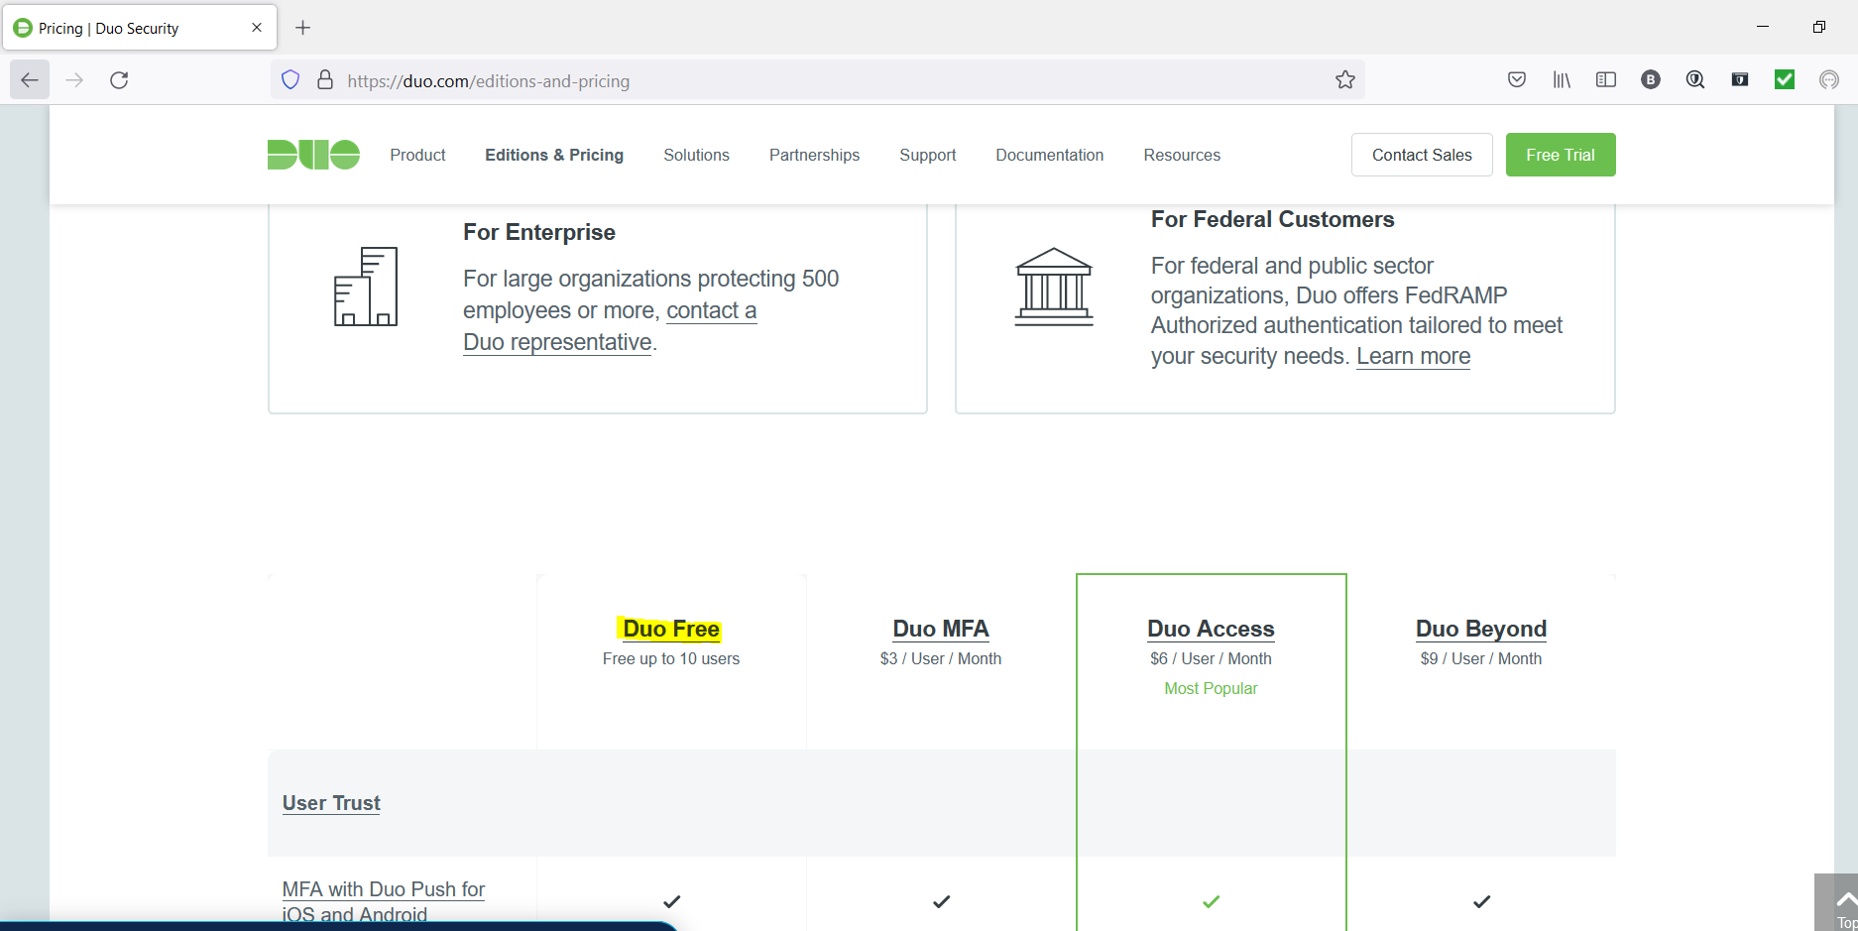

1. Next you will see the details about the free version of Duo Mobile. Select Start a Free Trial

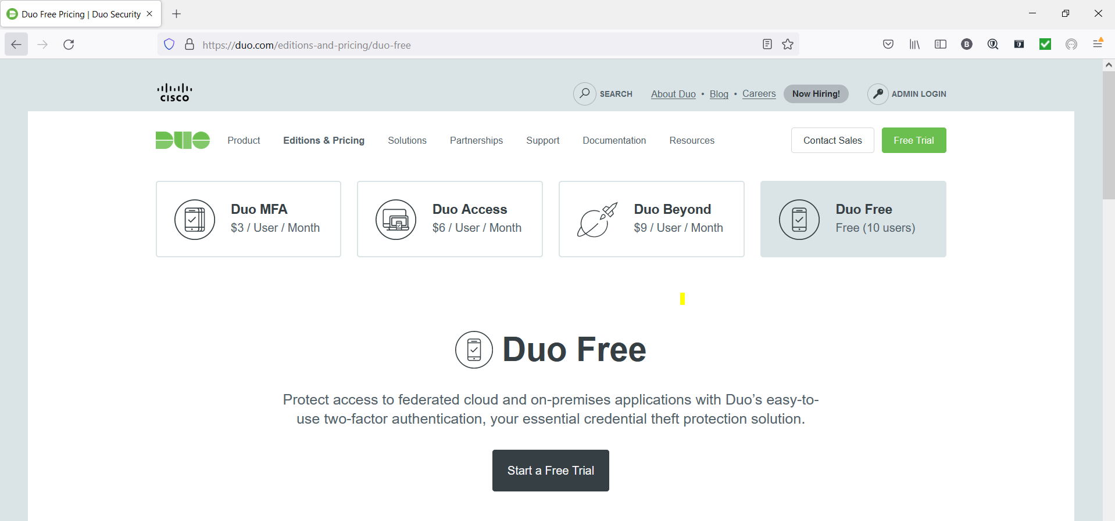

1. You will be presented with some fields. Fill these out with your information. Make sure both boxes are checked like shown below. Also, select the box confirming you are not a robot. Select Start My Trial.

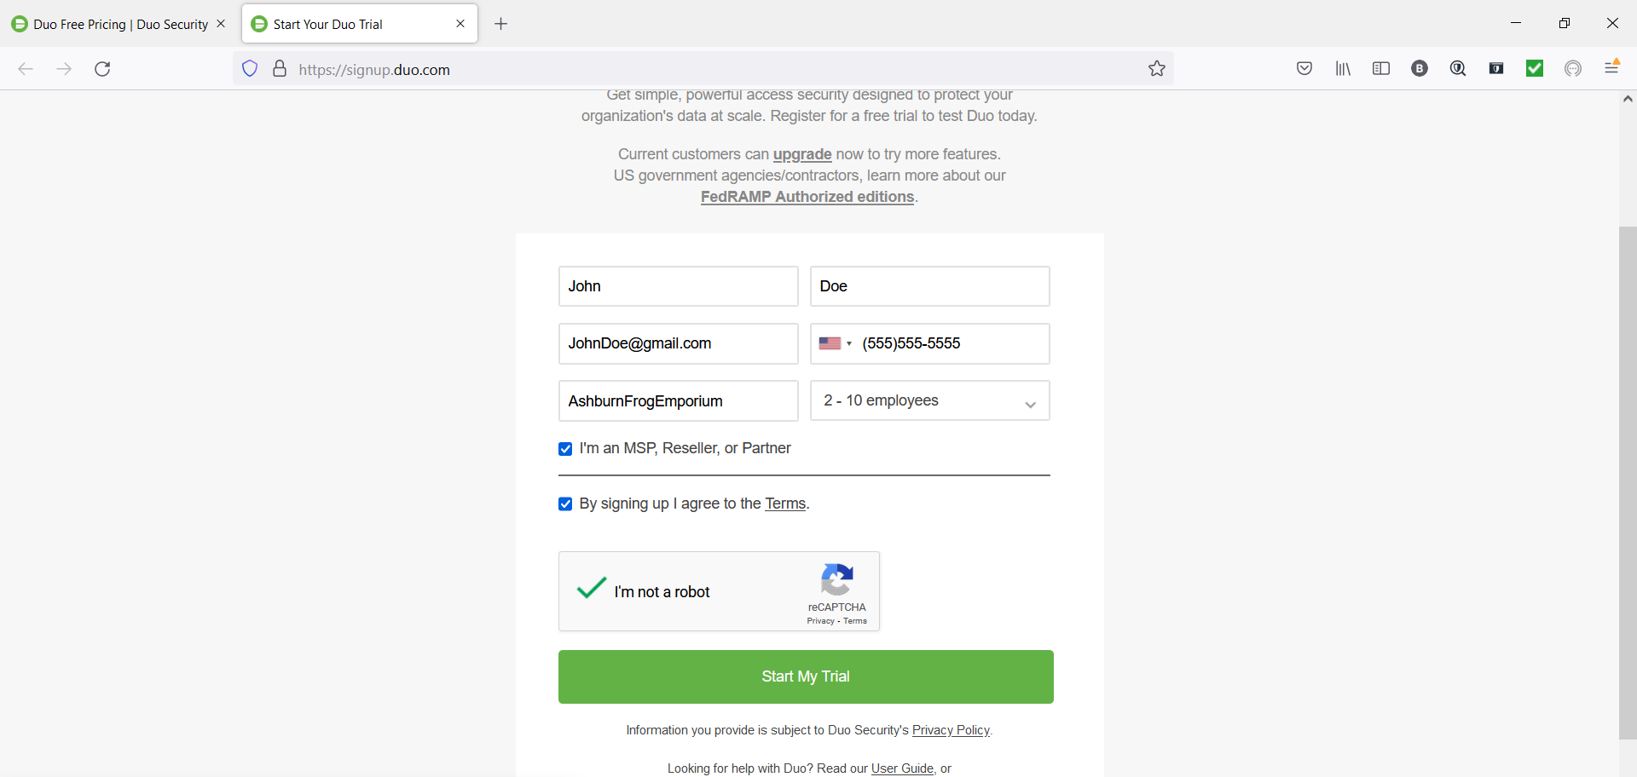

1. You will be prompted to check your email. You should have received an email from Duo Security. Select Verify Your Email.

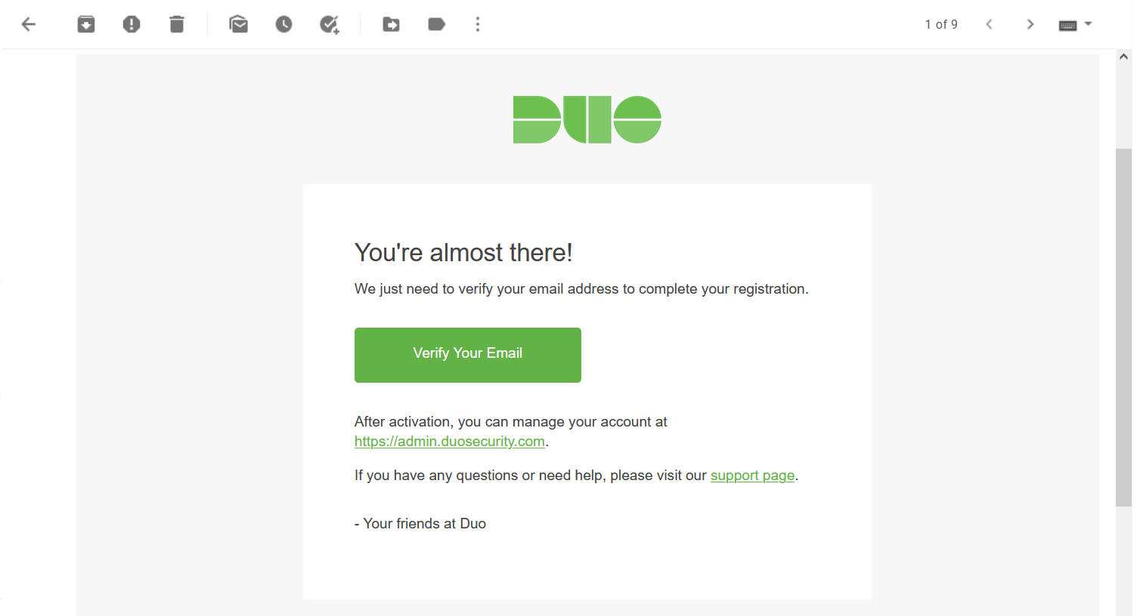

1. You will be redirected to a new web page titled Duo New Admin Setup. Select Get Started.

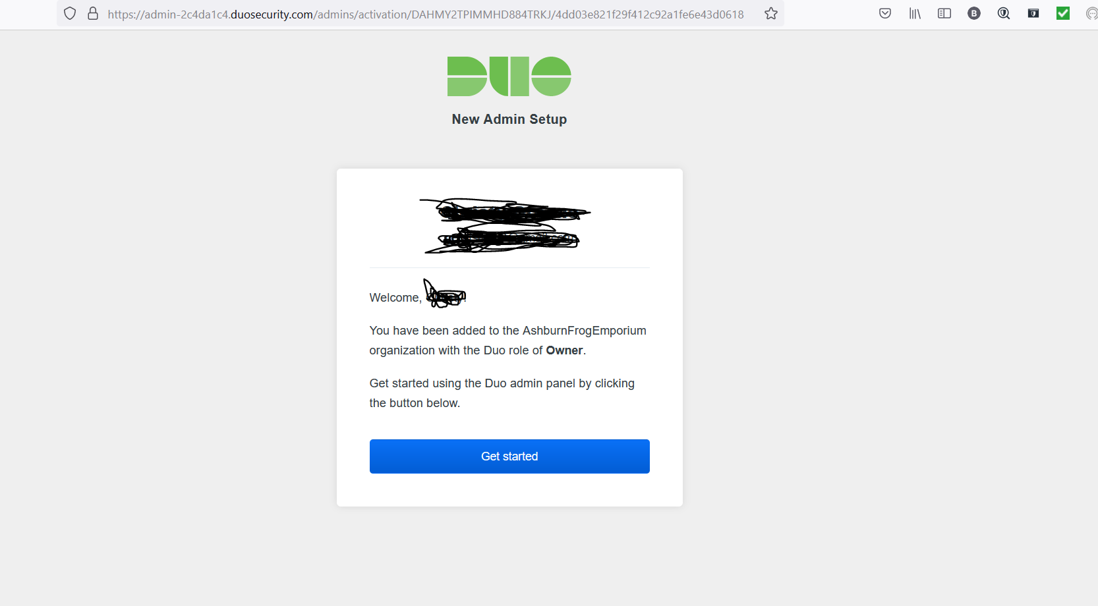

1. You will be prompted to create a password and confirm the password. Ensure the password is strong and something you will remember

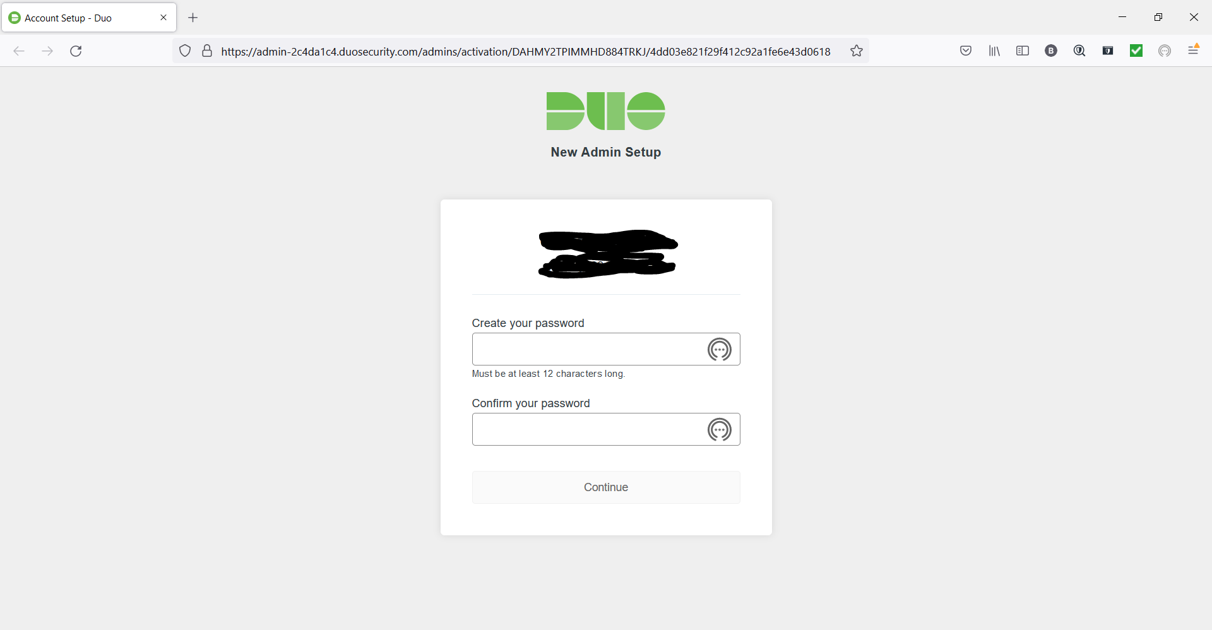

1. Next you will be provided with a QR code to scan with your phone on their app.

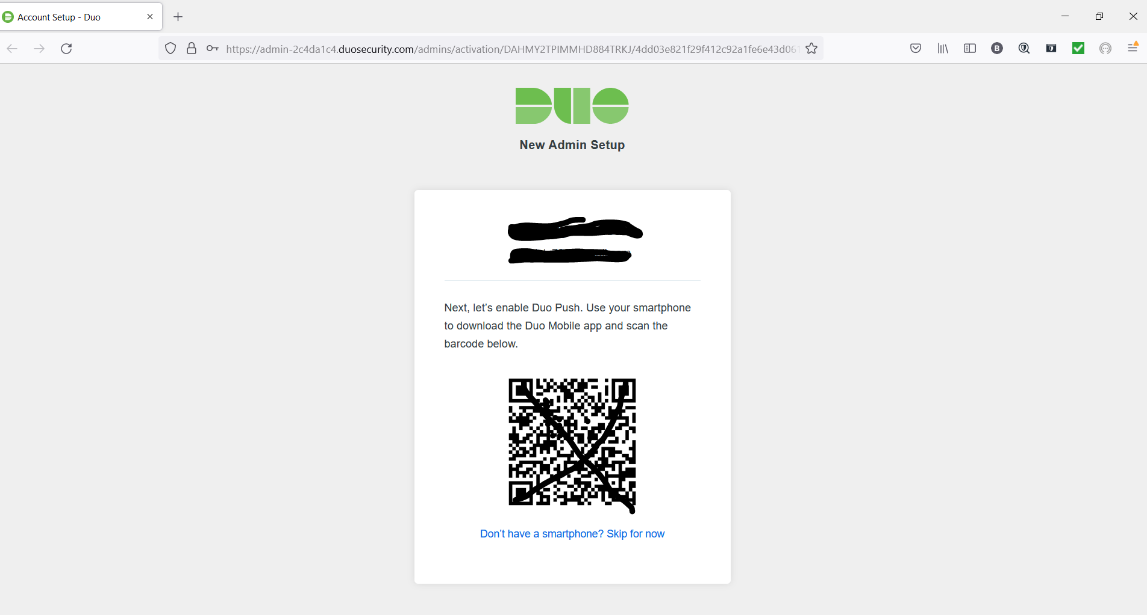

1. Next, download the app for duo mobile. This will be accomplished by accessing the play store for android devices or the app store for ios devices.
2. Once you have opened the app, you will enter into the search bar “Duo Mobile” as shown below and select the download button next to the appropriate app. Once it has downloaded, select the open app option.

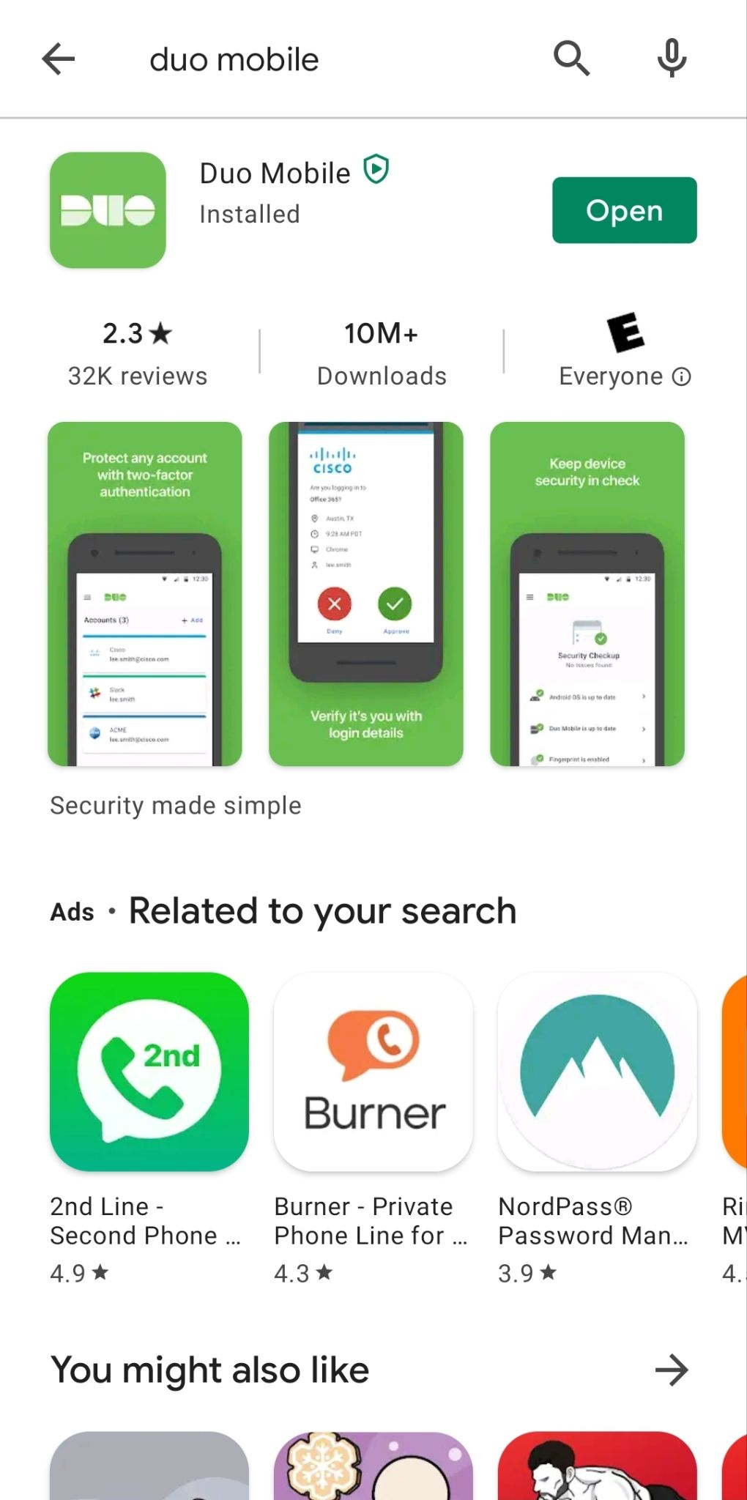

### Configuration

1. Once you open the app on your mobile device, you will be given two options. You will select “Set up account”. The other option is “I have existing accounts”, this is for once you have already set it up and are adding new devices.
2. Select the option for scanning the QR code and scan the QR code provided instep 7 of installation.
3. You will be prompted to confirm the name of the account. Confirm it matches what you typed for the company name in step 3 of installation. Select save.
4. You will see a screen on your phone indicating the account has been linked.
5. As a user you should start by selecting the Practice option. This will run you through a few scenarios and teach you normal activity on the application.
6. When prompted about Improving your experience, select Continue. This is allowing the app to send analytics to the distributor, which will help the upkeep of the application
7. Next, you will be prompted to log into your admin account, log in.

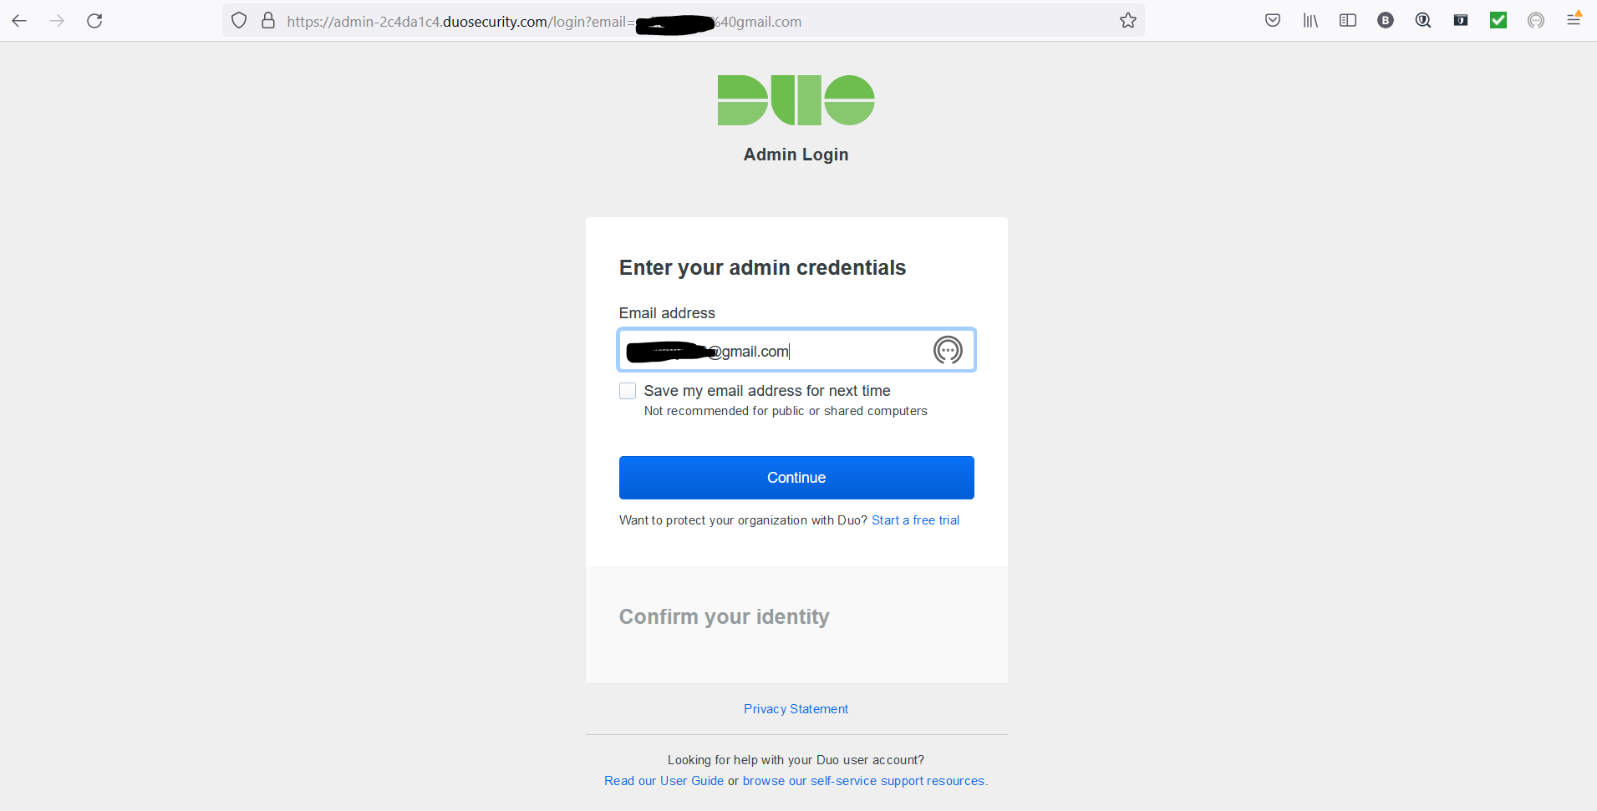

1. Once you log into the Admin account in the browser, you will be asked to enter a code. Select Duo-Push and select the checkmark on your phone when it pops up. .

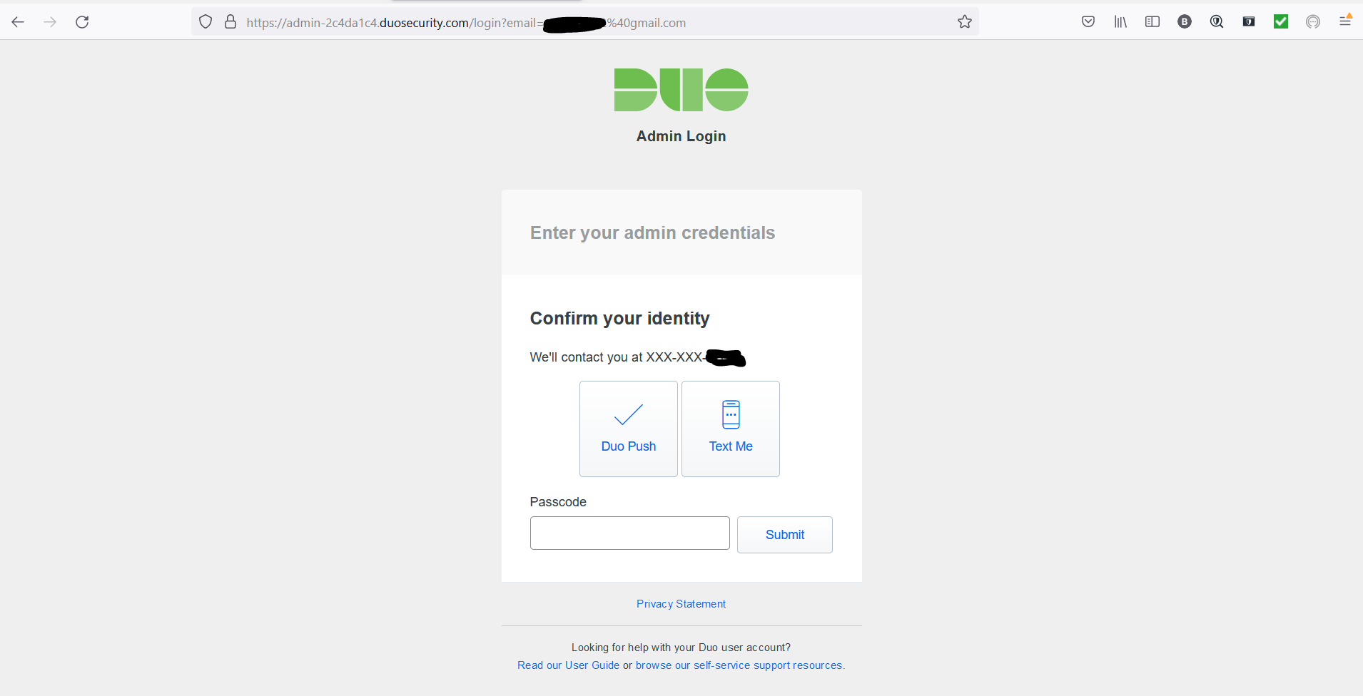

1. You will see a Congratulations message on your phone. Select OK.

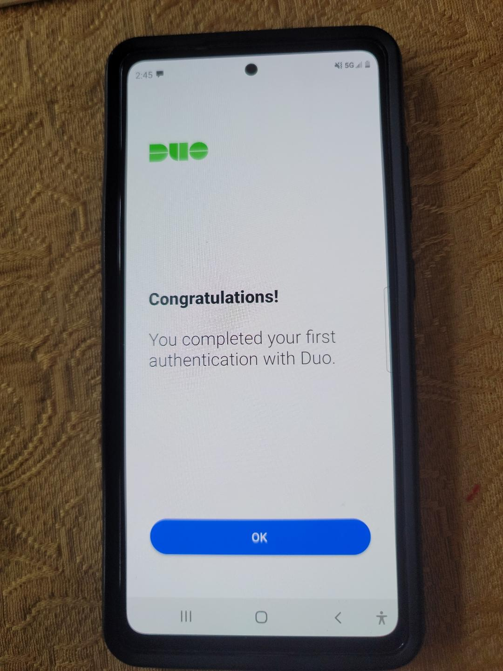

1. You should now see AshburnFrogEmporium in the app.

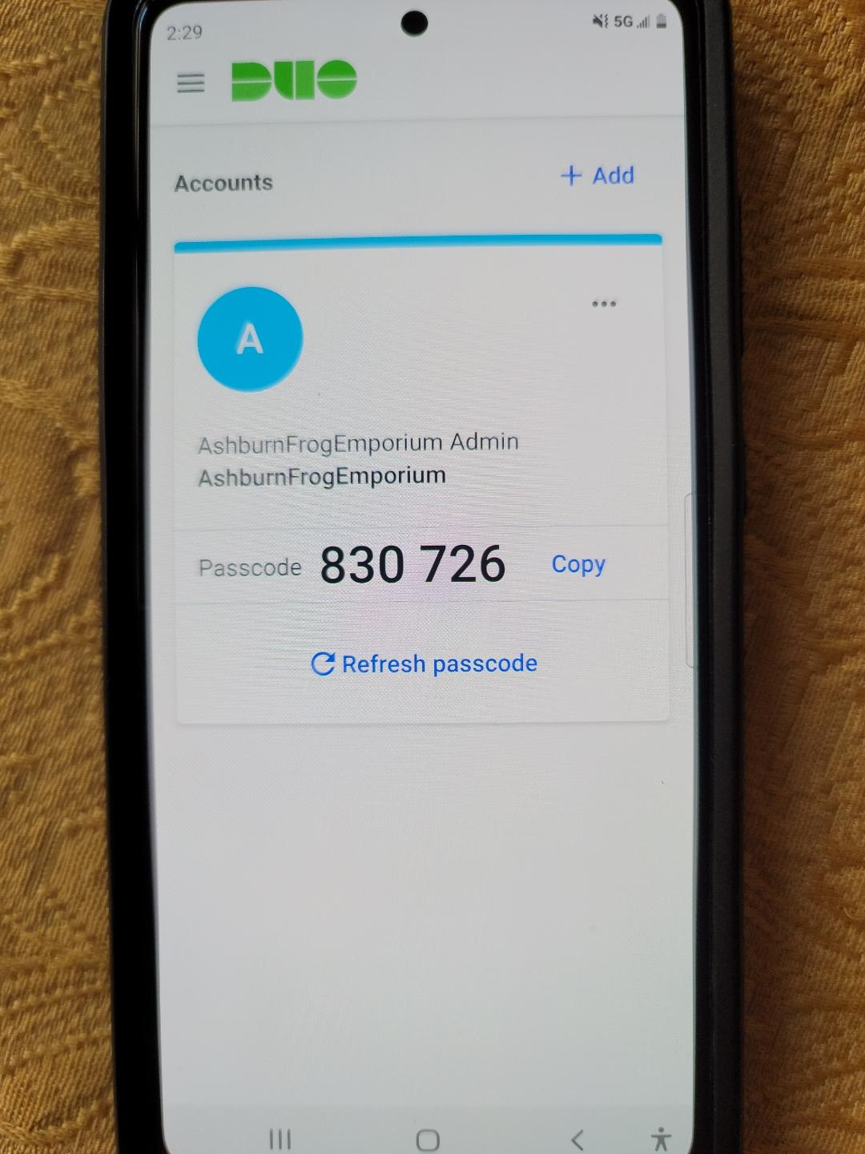

1. You now have access to the Admin Dashboard for Duo Security. From the dashboard you can monitor the users, the times the authentication has been used and set up new accounts to attack 2fa to. There is some limitations to this, however this tool is effective for business use, because it can be attached to products such as Workday and Salesforce.

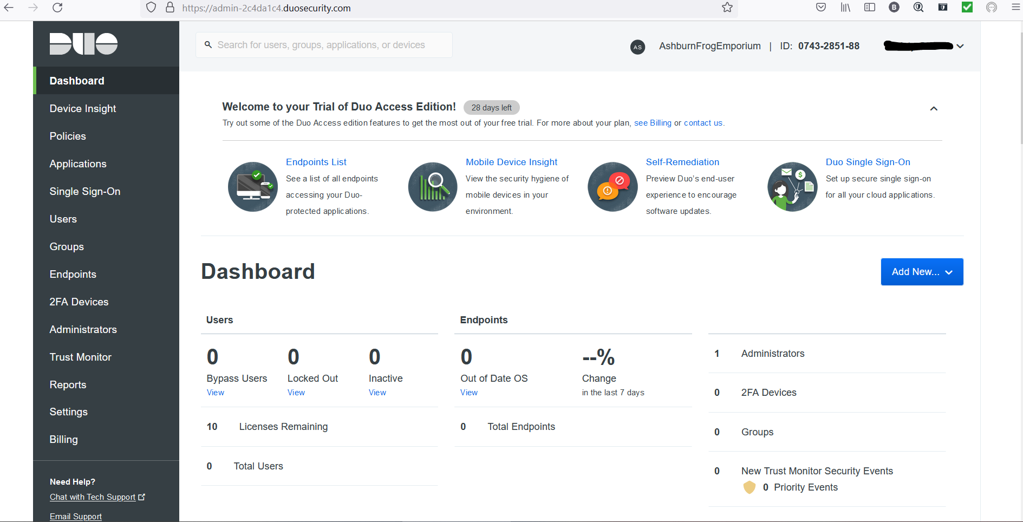

1. Next we will configure some settings on the admin dashboard. Select Settings on the left hand side of the dashboard and scroll down to Help Desk

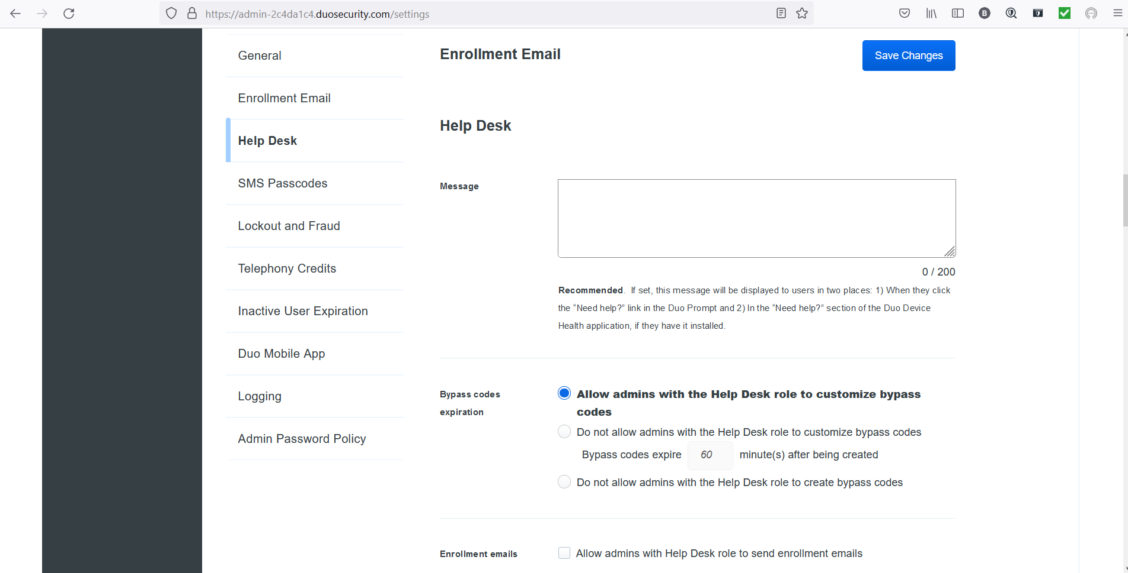

1. This will allow a message to be displayed when help is needed on the application. We can include contact information for who to contact if they need assistance. Type in a message for your users to contact you if an issue is detected.

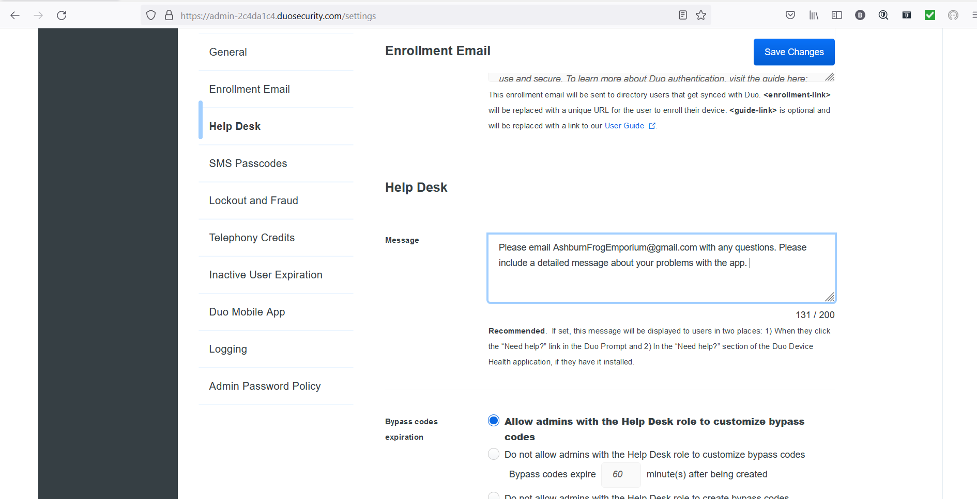

1. Next scroll down to SMS Passcodes. Click the circle next to Expire SMS passcodes after a set time. Change the time to 720 minutes or 12 hours.

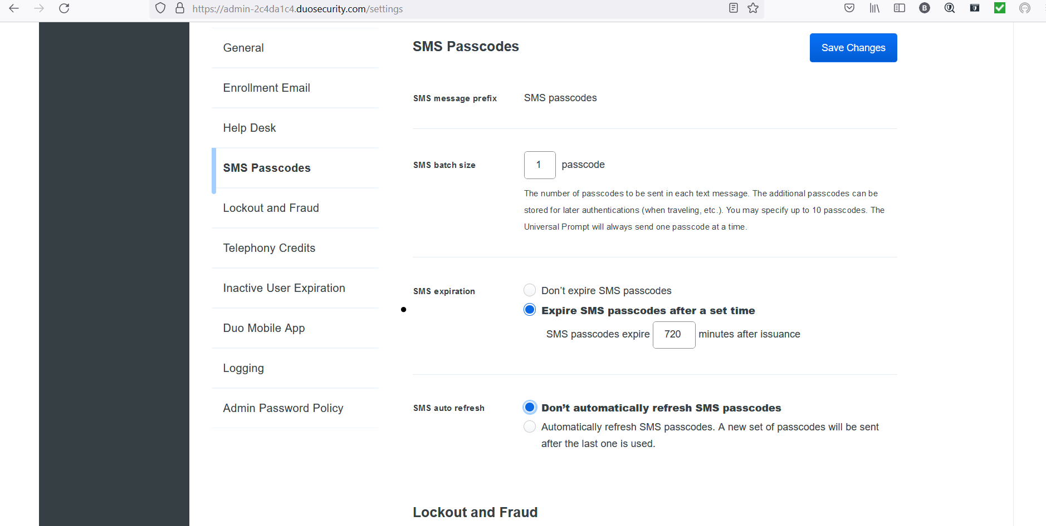

1. Next scroll down to Lockout and Fraud. Put a check the back next to Block anomalous Duo Push Attempts.

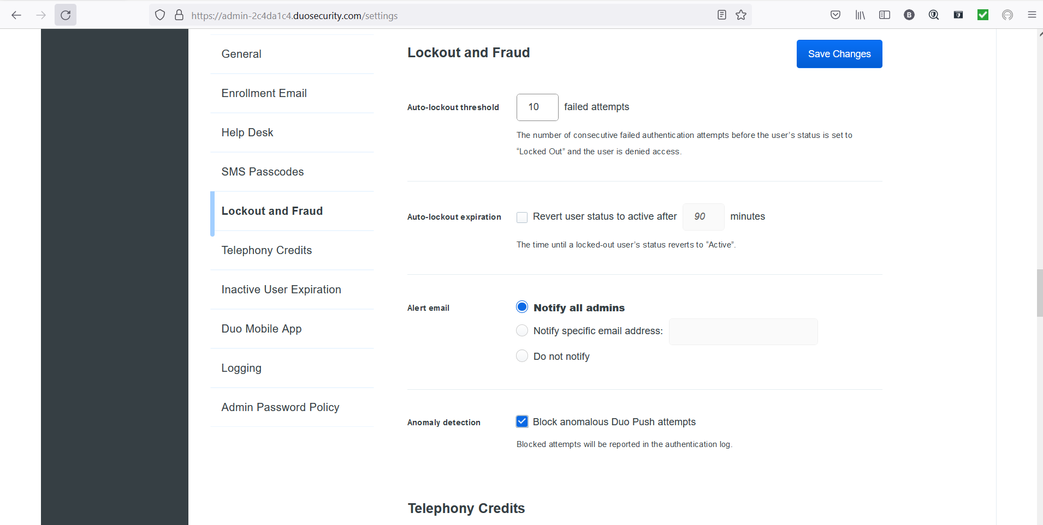

1. Next Scroll down to Inactive User Expiration, set user accounts to expire after 90 days of inactivity.

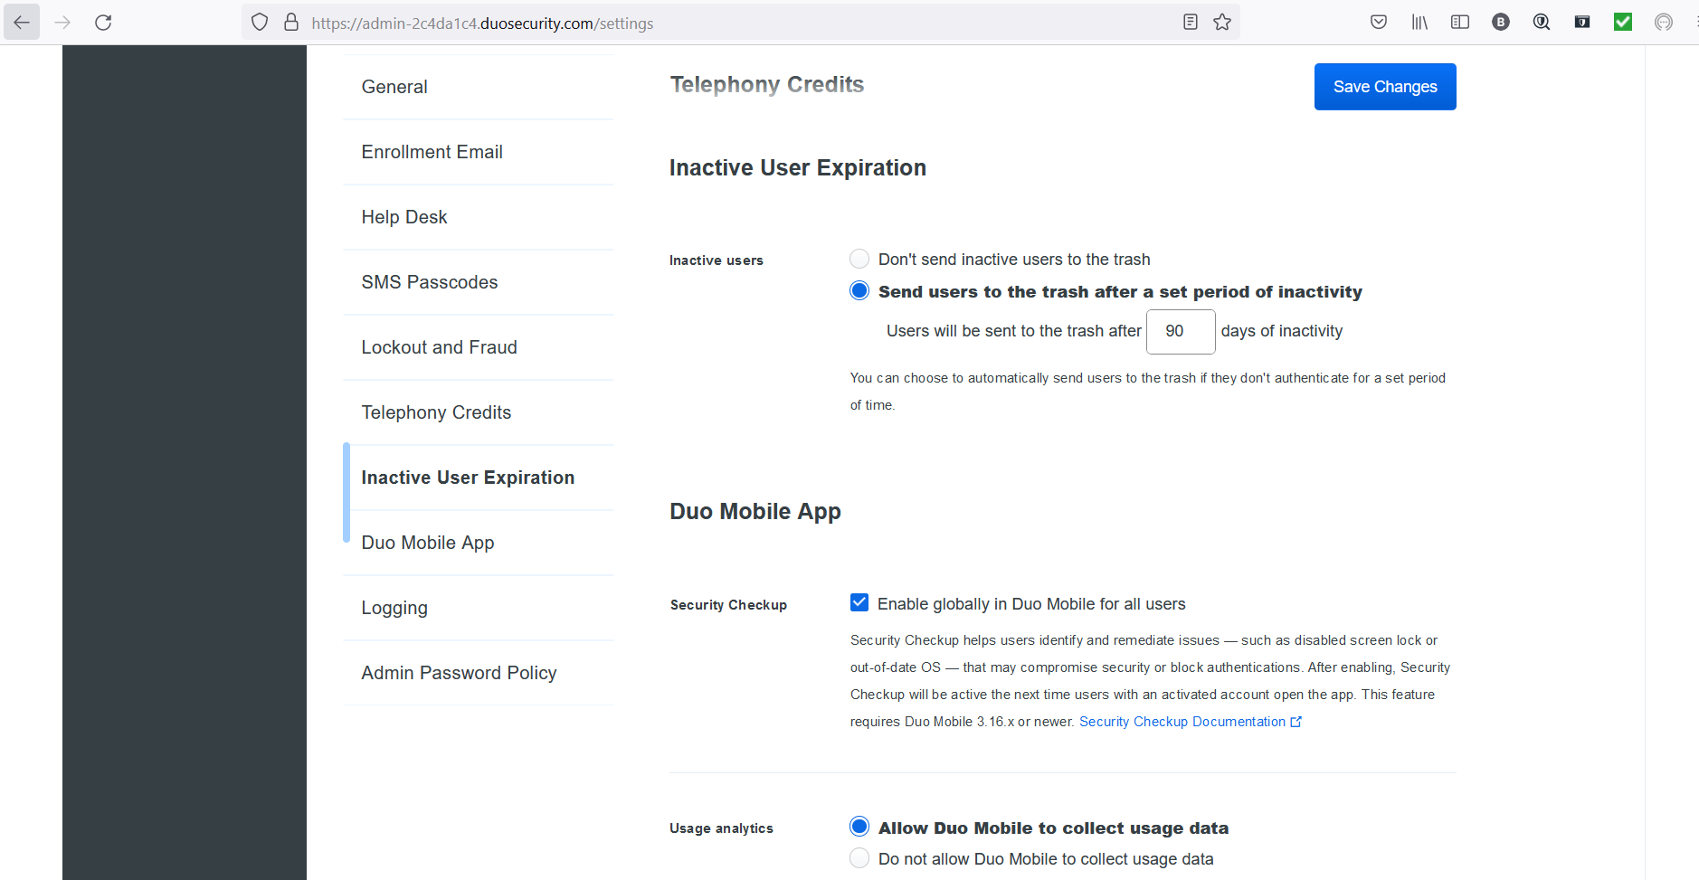

1. Finally scroll down to Admin Password Policy and ensure the character length is 12 and check the boxes next to uppercase letter,lowercase letter, number, and special character. Then select save changes in the top right corner.

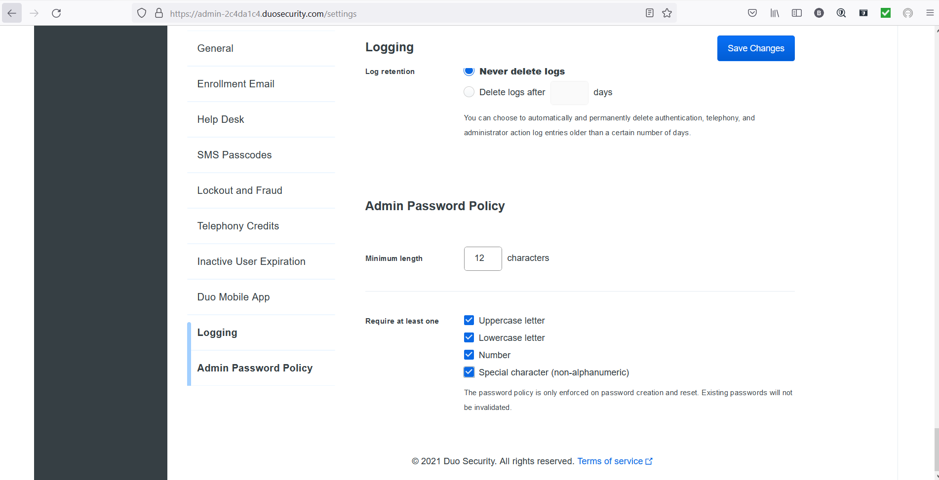

1. You should see a green banner across the top of the dashboard indicating that all changes were successfully modified.

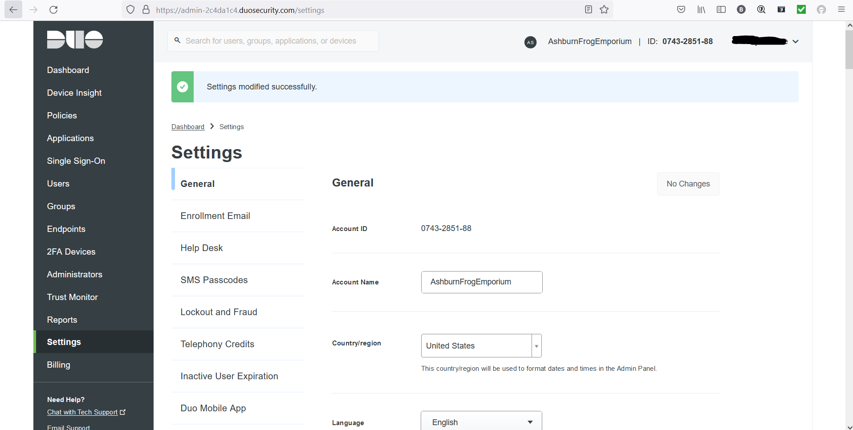

### Testing

1. We can test the authenticator by attempting to log into the admin account and denying access.

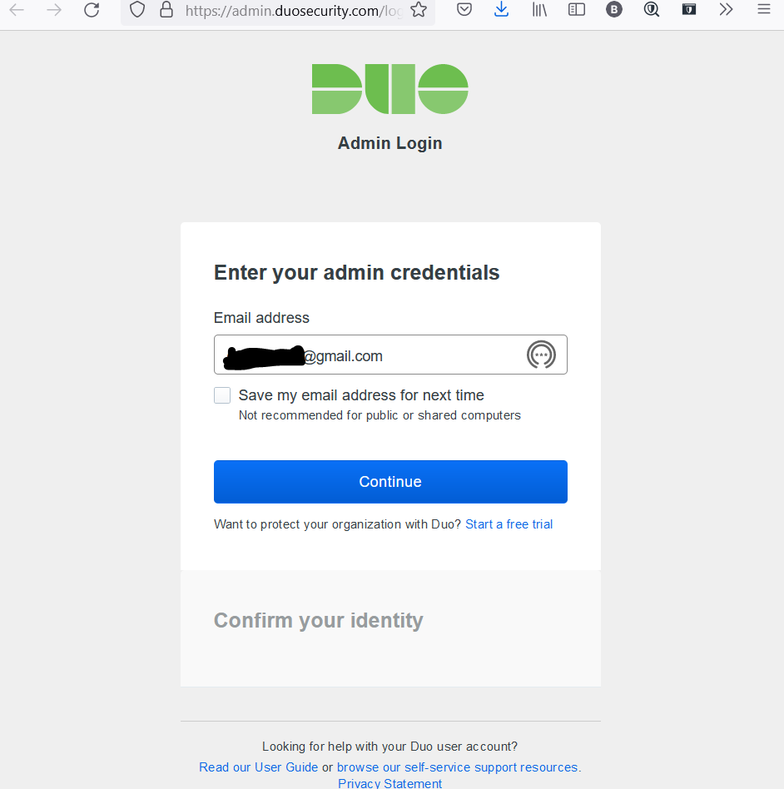

1. Once you log in you should receive a push notification, since this is a test select Deny.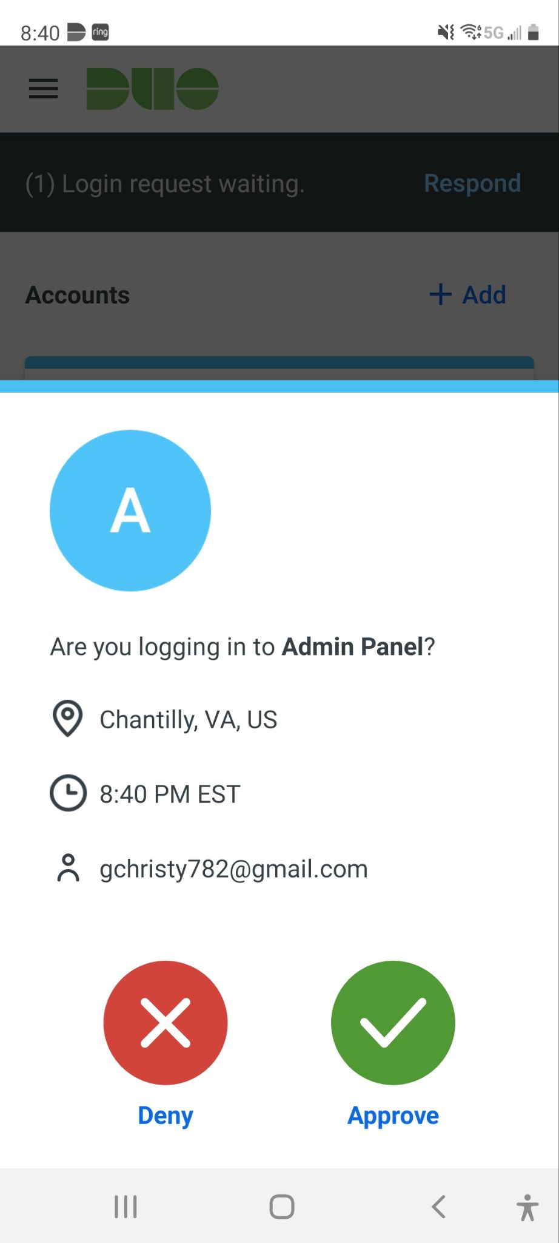
2. Once you select Deny, you will be prompted to answer if this was a suspicious long in. Select No since this was a test.

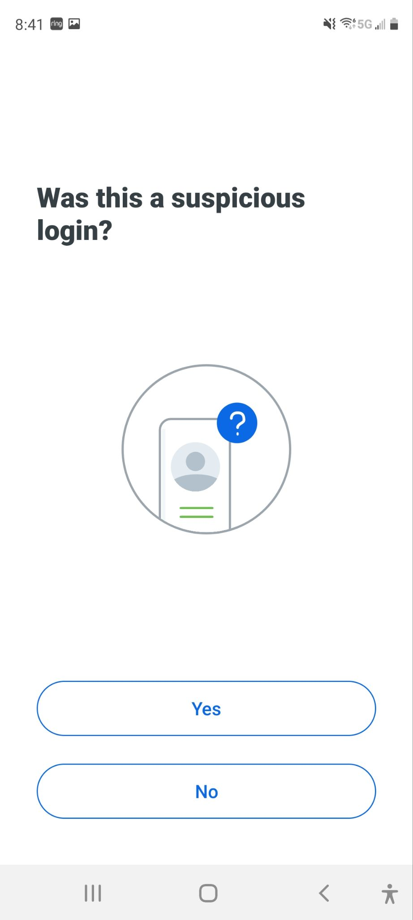

1. On your log on screen you should see the login attempt was denied.

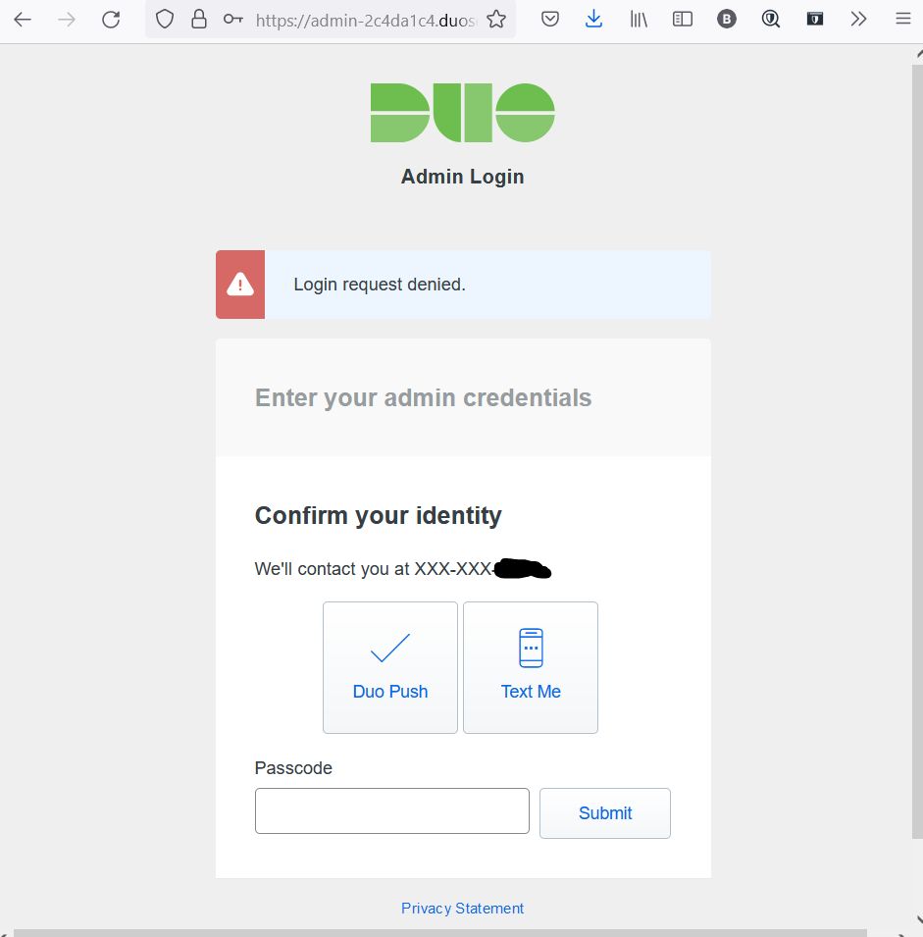

## Recommendations (Ryan)

Duo Mobile is used as a method to achieve two-factor authentication. This will maintain confidentiality by ensuring the only people who are able to log into our systems. Our security team recommends that all employees of Ashburn’s Frog Emporium have Duo Mobile installed on their smartphones and Duo Mobile be adopted by the organization. The following URL has vendor provided training, configuring and troubleshooting information.

<https://levelup.duo.com/>

<https://guide.duo.com/>

## Alternatives (Luis)

ESET Secure Authentication is the alternate Two Factor Authentication service that was identified by our team. With ESET Secure Authentication we will be able to use it to secure the local area network, Microsoft Web Applications, login information, VPN applications and services such as Office 365 including outlook, microsoft teams and word documents. It does this by requiring an additional one-time use password which can be delivered through SMS, the mobile application, email, hard tokens or a push notification. In the case that the authentication server that ESET Secure Authentication uses is offline then we will be able to authenticate the login using a hard token. This will ensure that even if their servers are offline that our users will still be able to login and will not deduct on the business operational time. Additionally, it will also employ protection to remote users when they try to log in until they log out of the remote connection. ESA also logs authentication attempts, locks accounts if the user fails too many attempts and will also log when the service is not running. It also has IP Whitelisting so that trusted sites that are frequently used, such as company portals, can be accessed quickly without impacting employee performance. The pricing plans starts at 69.90 per year for 1-10 users but can also be bundled with other services such as endpoint protection, full disk encryption, cloud app security and more to provide a comprehensive security solution using other ESET products.

# Enterprise Browser Management

## Information About Tool (Marcos)

Enterprise Browser Management is a tool that provides the securing and management of multiple browsers from a central console. It helps provide visibility on browser usage trends, track the websites visited by users, restrict access to the web, enforce security configurations, control browser add-ons, and ensure compliance with required browser security standards. In addition, the Enterprise Browser Management tool will assist our team in combating web-based attacks.

There are the four aspects associated with browser management: obtaining visibility, exercise control, enforce security configurations, ensure compliance. Enterprise Browser Management provides visibility into a network, including which browsers are present, the default browsers used, the add-ons used in each browser, as well as the potentially harmful add-ons if any exist in the network. Our IT security unit can also create their own reports for viewing specific browser details.Establishing controls will enable or deny end users access to certain websites and add-ons based on their reliability. Our IT admins can decide which trusted sites can be opened on users' browsers and which should be isolated to a remote browser. This will prevent the possible interaction of sensitive business data with malware hosted on untrusted sites.Browser management provides security configurations aimed at preventing and mitigating threats encountered on browsers. Browser Security Plus provides these configurations in groups of solutions such as threat prevention, data leakage prevention, and browser customization, which our IT admins can configure and deploy to end users from a central console.To ensure compliance, Browser Security Plus provides a predefined set of rules that end users need to follow to prevent cyberattacks. In addition to the Enterprise Browser Management predefined set of rules, our team can create their own compliance standards that work best for Ashburn’s Frog Emporium. Browser management is the key to protecting computers from browser-based cyberthreats and attacks. Browser Security Plus offers comprehensive enterprise browser management and end-to-end security for all aspects of browsers.

## Prerequisites (Marcos)

* The following platforms are supported by Enterprise Browser Management
* Microsoft Windows 10
* macOS
* There are two editions associated with ManageEngine’s Enterprise Browser Management. There is the Browser Security Plus Free edition, and Professional edition. The annual cost of each tier as followed:
  + Browser Security Plus Free: $0.00 (25 computers / 30 free trial)
  + Browser Security Plus Professional: $345 – $19,495 (Per year / pricing of the paid edition varies based on the number of computers you have and the number of user licenses you need)

## Instructions (Ryan)

### Installation

1. Navigate to<https://www.manageengine.com/browser-security/download.html> and select Download

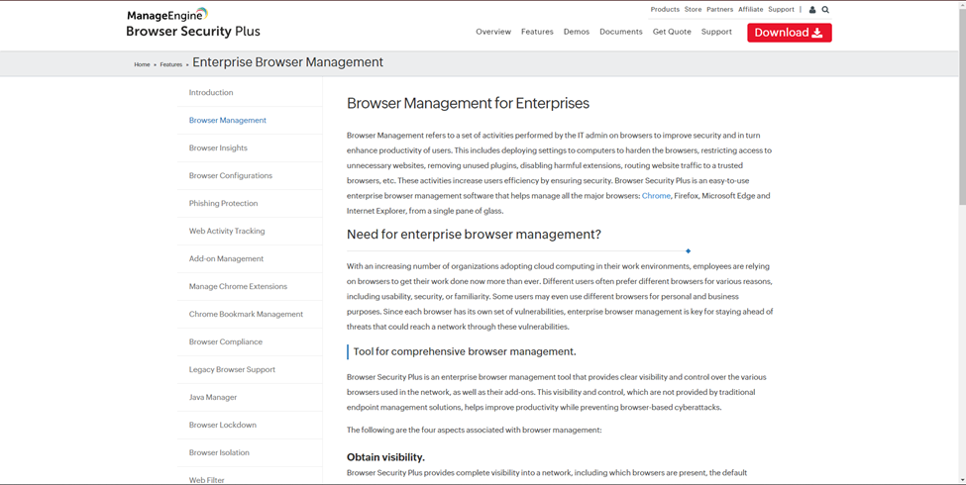

1. Select the location you wish to save the Setup file to

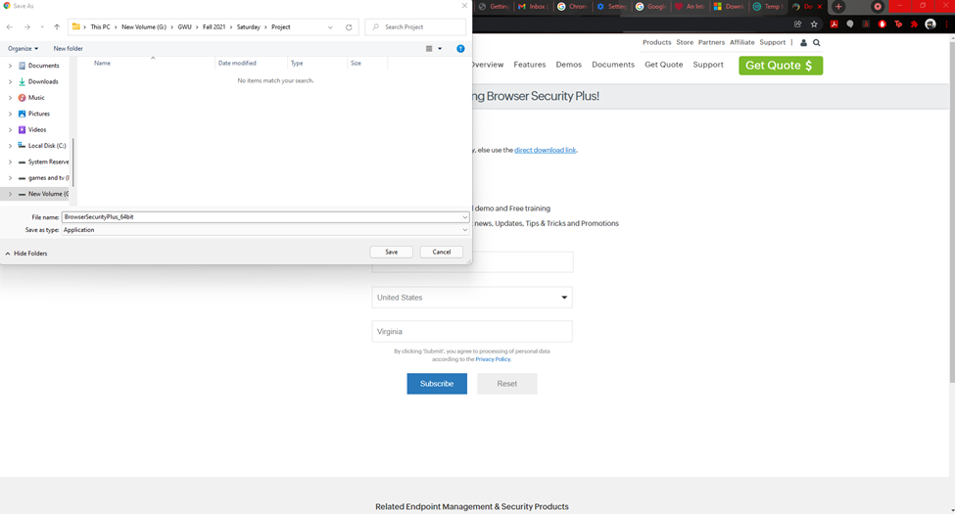

1. Once the download is complete, open download file. Right click and select Run as administrator.

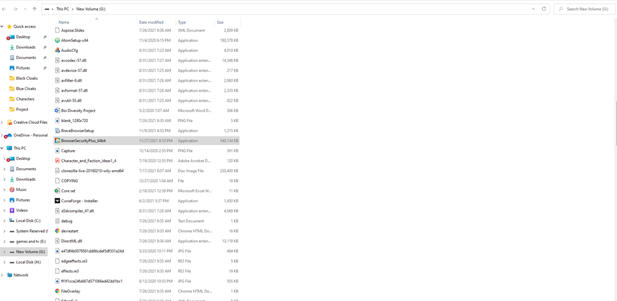

1. At the Welcome prompt, select Next.

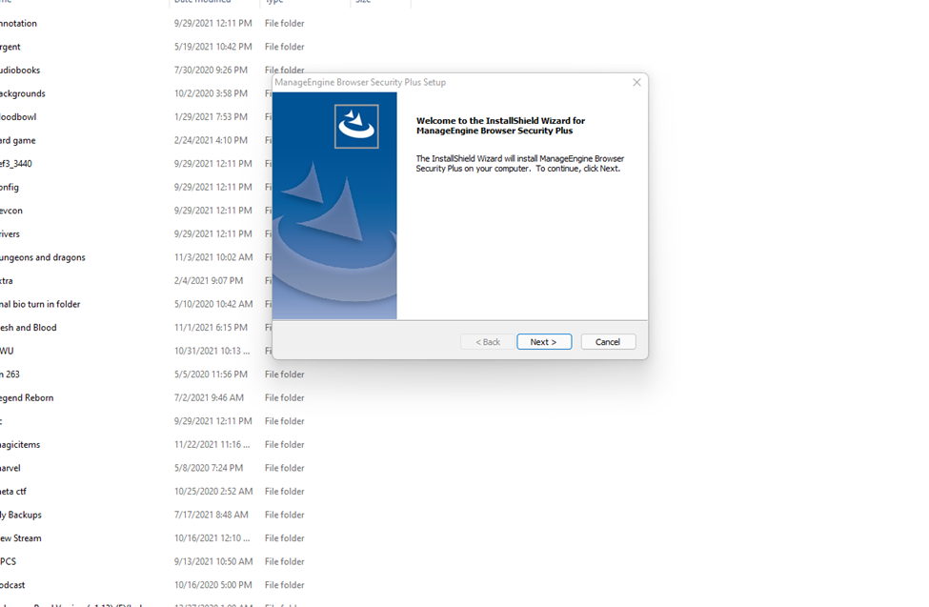

1. Read and understand the License Agreement, once this has been done select Yes to accept the licensing agreement.

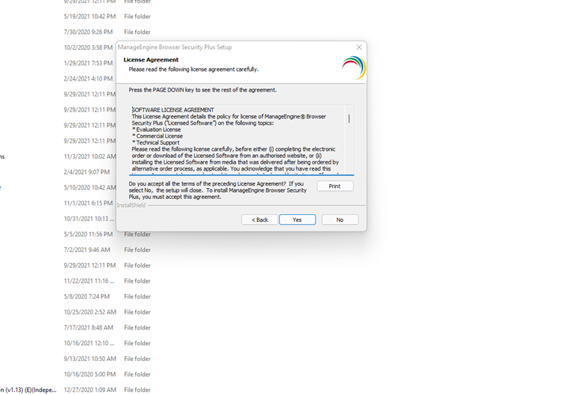

1. Select the folder in which the files will be installed. Then select Next.

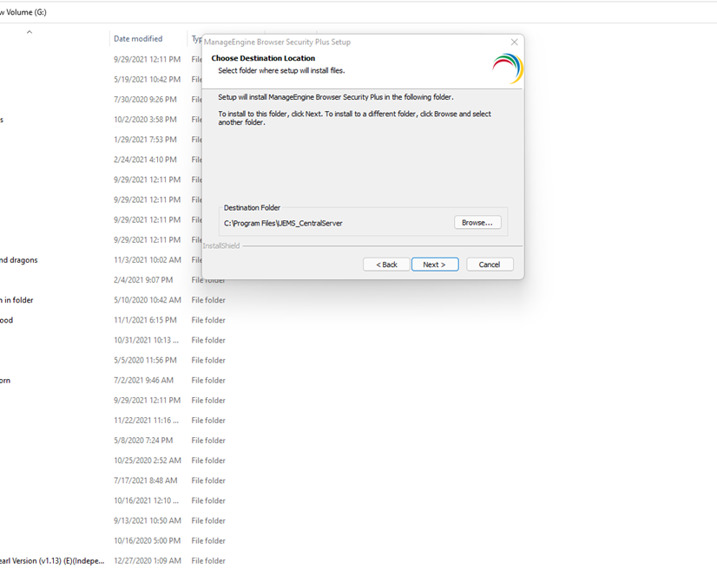

1. Enter the HTTP port and the HTTPS port numbers. 8020 and 8383 come predefined and should only be changed if your enterprise uses different Web Server ports. Then select Next.

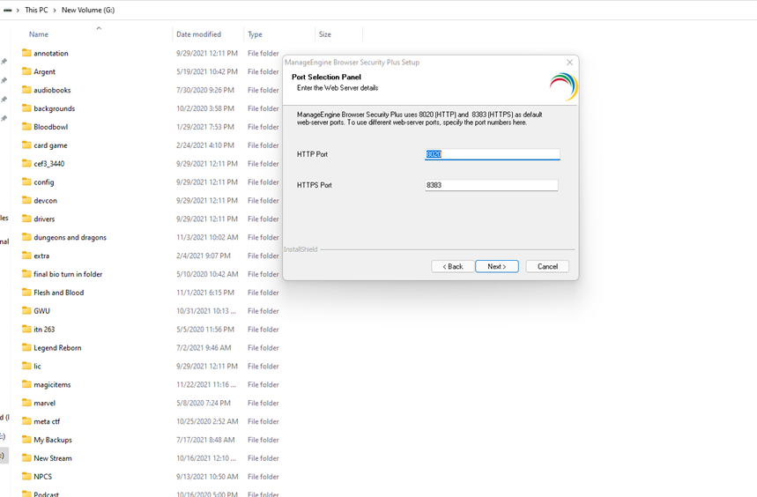

1. Create or Select program folder for the program icon to be added too. Then select Next.

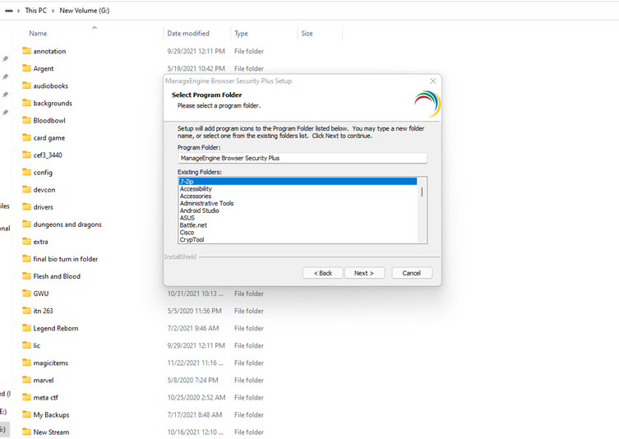

1. Review all selected setting provided and select Next

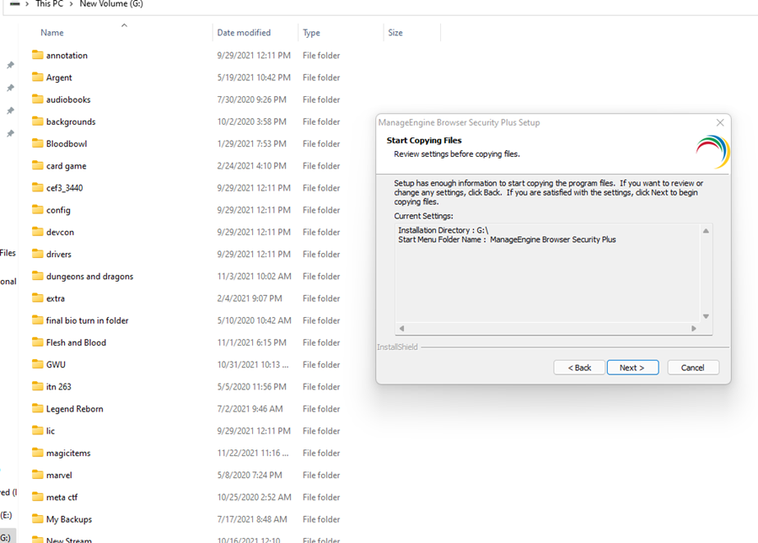

1. It will undertake the install process.

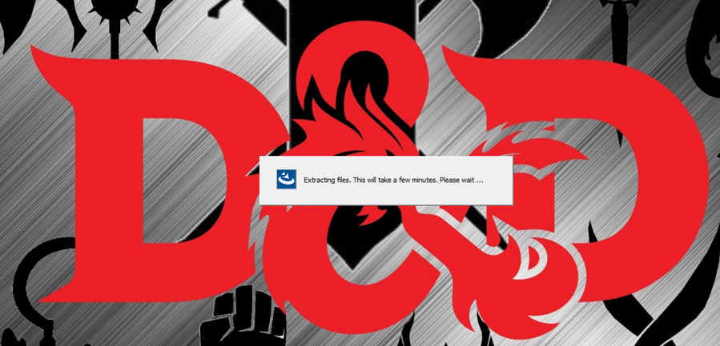

1. If Windows Defender Firewall would block features, select Allow access.

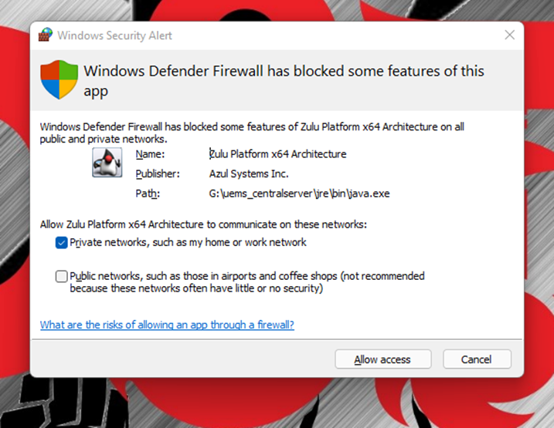

1. You may register for technical support but currently select Skip.

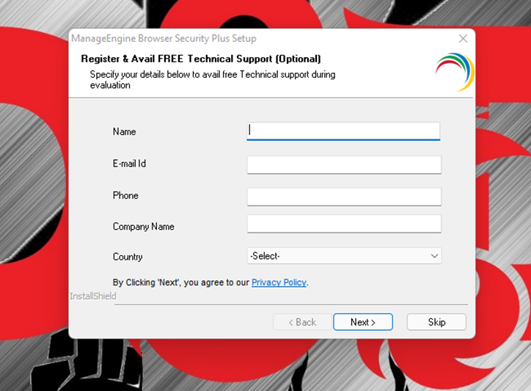

1. Leave Yes, Start Browser Security Plus checked and select Finish.

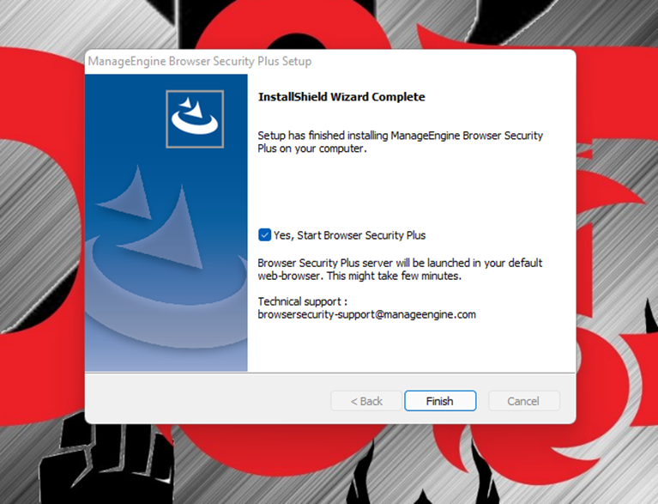

1. You will be taken to the login page, here use the default password. This password will be hardened in a later step.

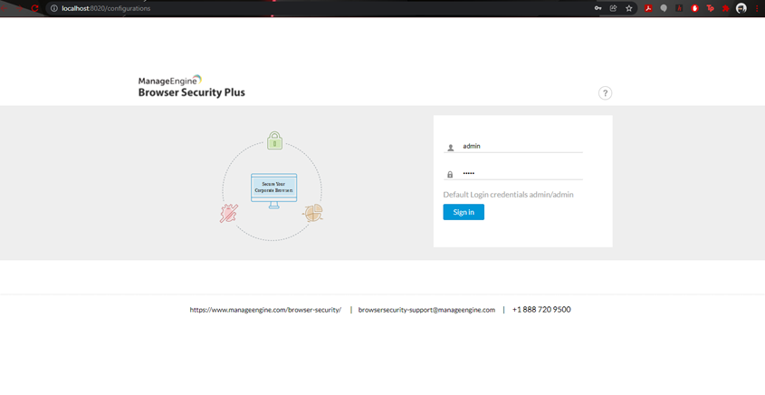

1. You will be asked to Install Agent on your computer. This agent will gather information about Browser usage and allow that computer to be a part of group policies.

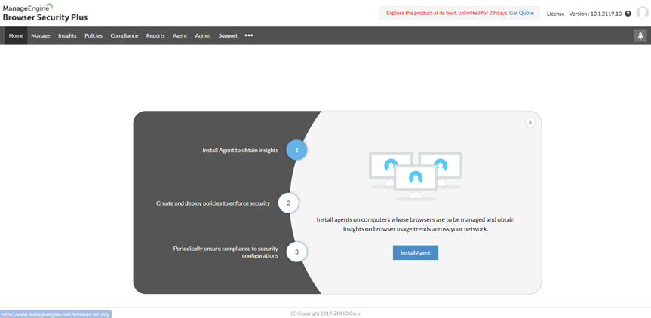

1. After selecting Install Agent, you will be taken to another screen. Select the blue button that reads Download Agent and select Windows Local Agent.

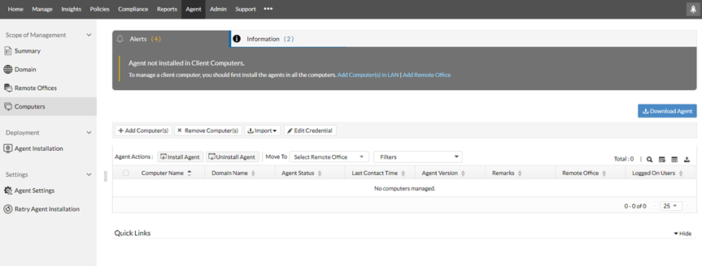

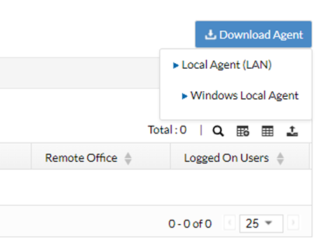

1. Select the target location of the Agent file. The select Save.

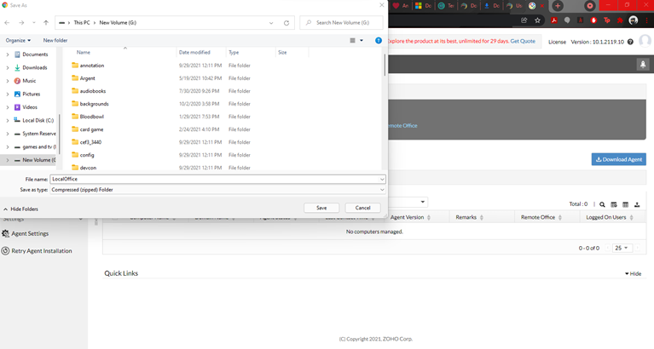

1. Open the Zip file. Then select localsetup.

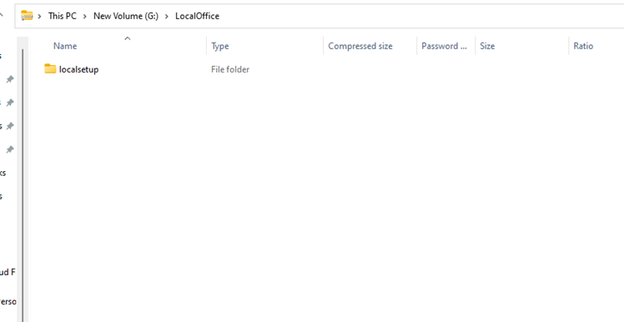

1. Then double click setup.

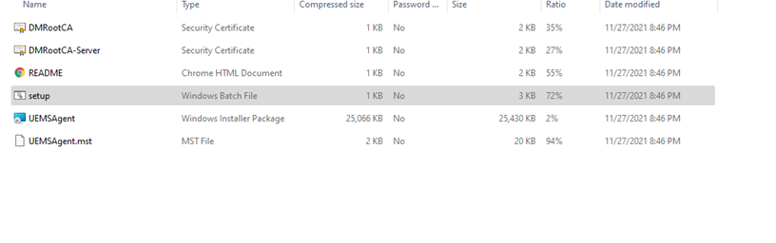

1. This will open the command prompt. Press 1 to install the Argent.

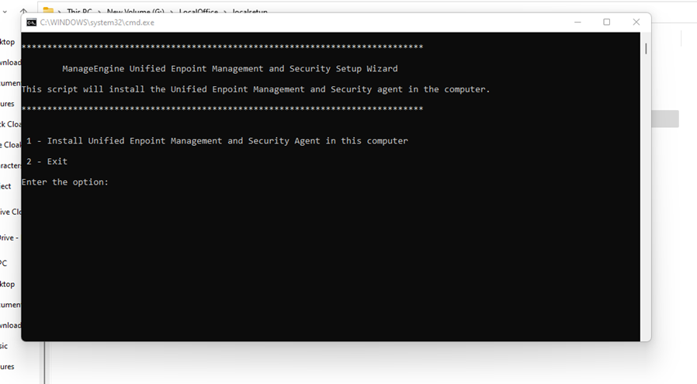

1. When the Agent Setup Wizard Opens select Next.

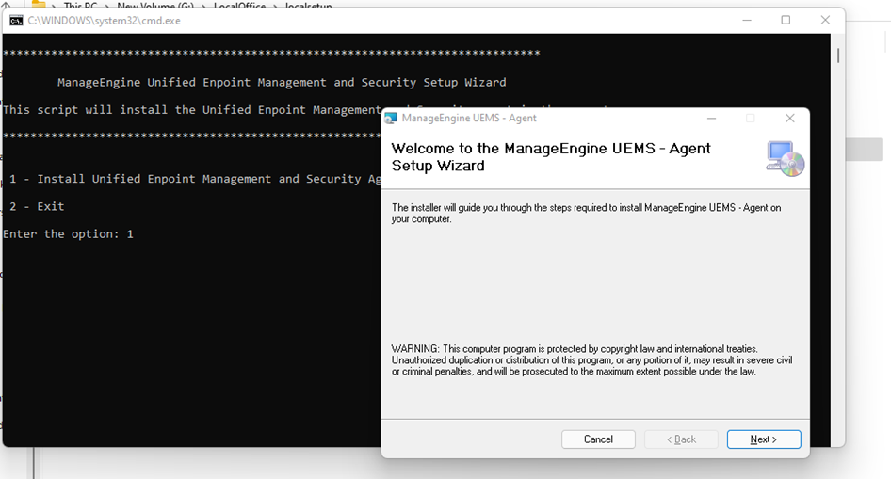

1. Confirm the installation by selecting Next.

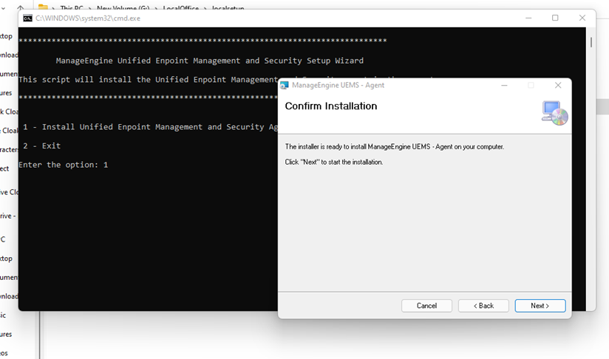

1. You will be taken to the status screen for the Agent installation.

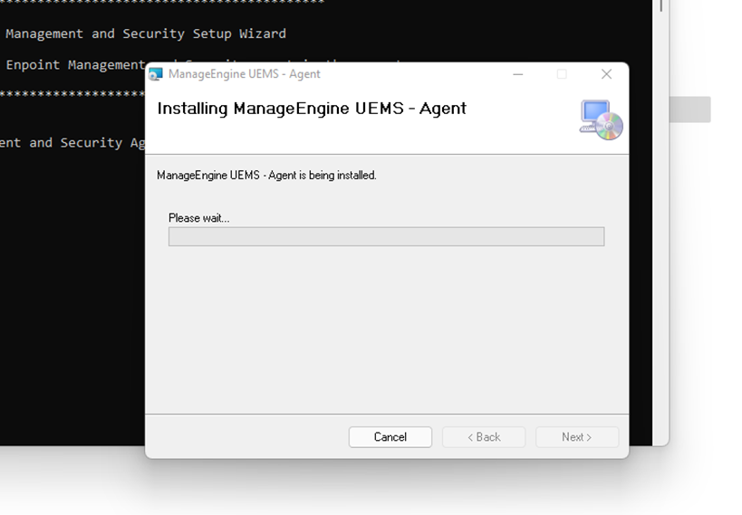

1. Once the installation is complete, select Close.

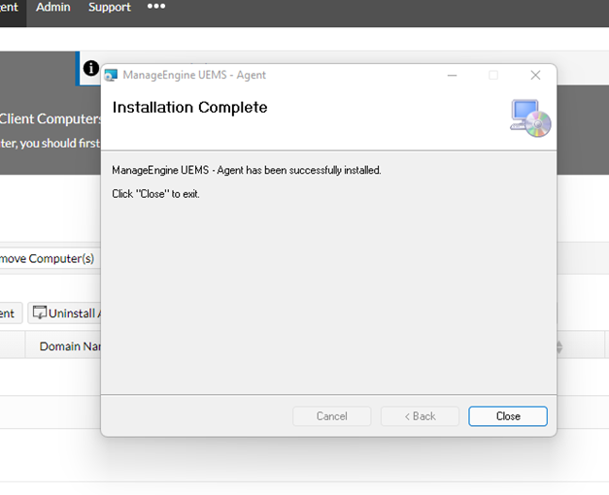

### Configuration

1. You will find the following in the Agent Management Window.

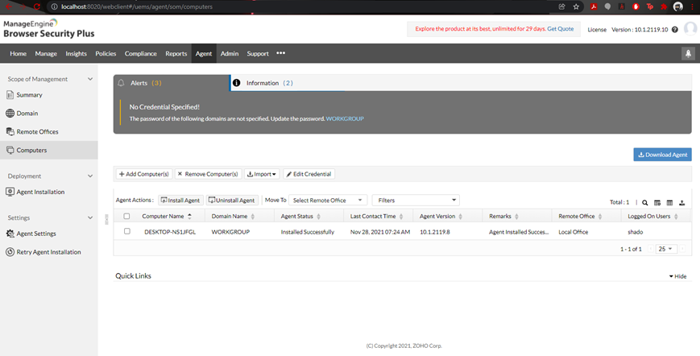

1. Navigate to the Mange Screen and Select Create Group.

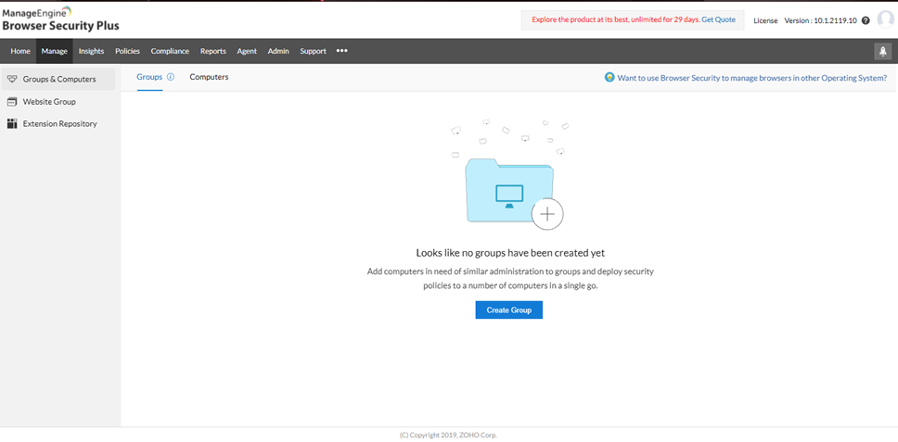

1. Then create a Group Name and leave the Category as Static as this group will not change. Because there is only one computer that has an Agent installed on it currently, our group will consist of this single machine. Select the only Available Computer and drag it to the Added Computers section. Then Select Save once you are done.

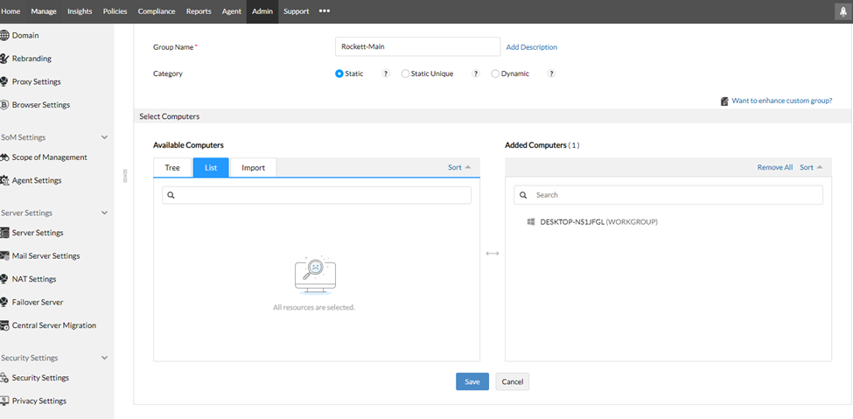

1. Under the Admin section, there is a subcategory entitled Custom Group. Here you will find the group we just created.

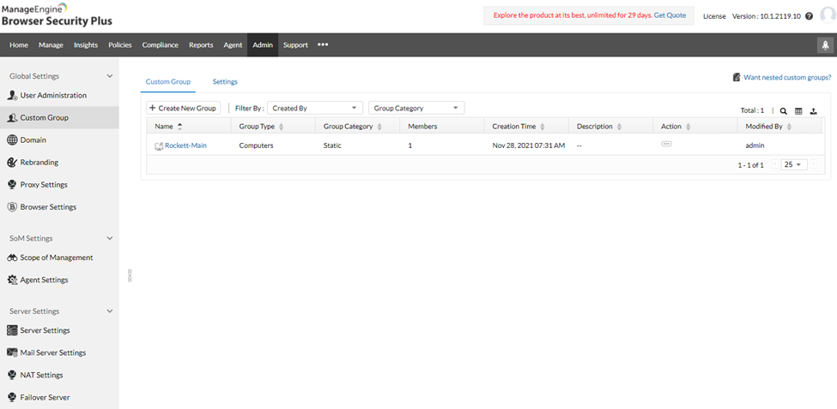

1. Navigate to the Policies section and you will find multiple features you are able to configure for your enterprise.

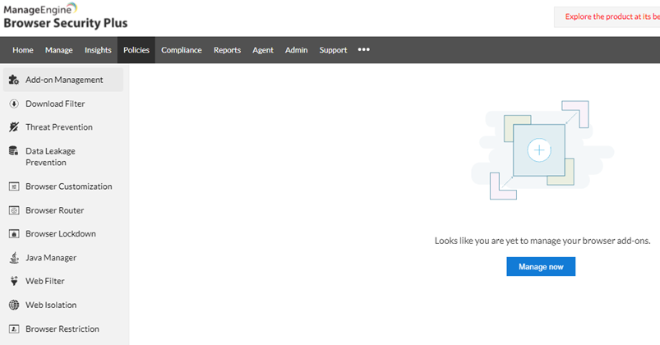

1. We will look at four of the main subcategories, the first being Add-on Management. Here you are able to Blacklist Extensions by their Extension Identifier. These can be Googled per Extension or you are able to upload a CSV File containing a list of Extensions to block.

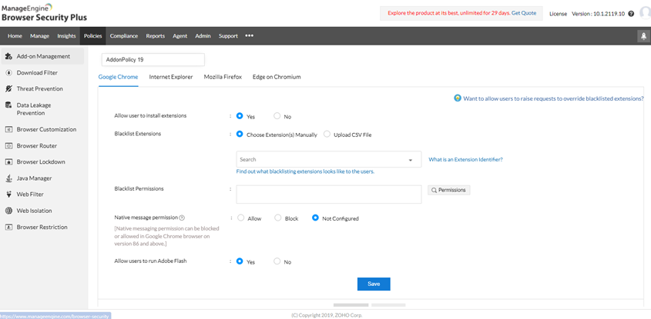

1. Next, we will look at Download Filter. Here you be able to block all downloads or set conditions to block or restrict the ability to download.

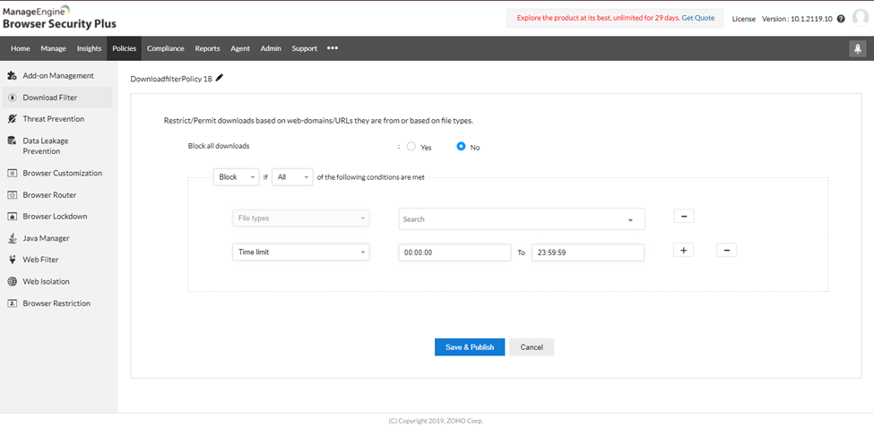

1. Now we will look at Threat Prevention. Here you will find a list of different policies that would reduce the chance of threats being able to exploit a vulnerability.

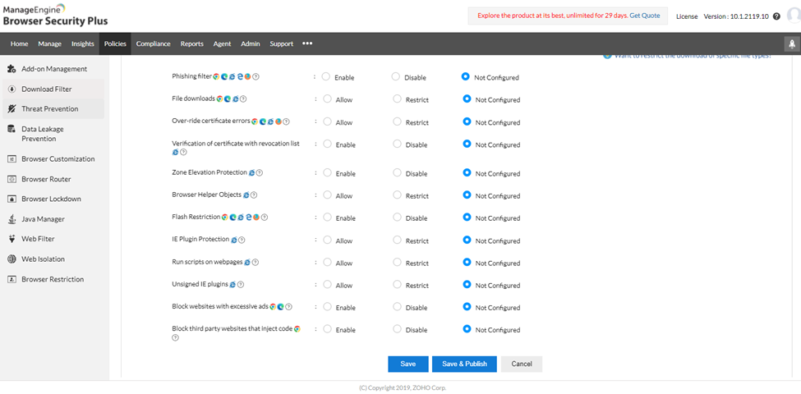

1. Lastly, we will go to Web Filter. Here we will be able to set security restrictions, URL Filters, and what the appearance of the blocked page will be. We will be selecting all of the Security Restrictions for your computer. At the bottom of the page select the Save and Publish button.

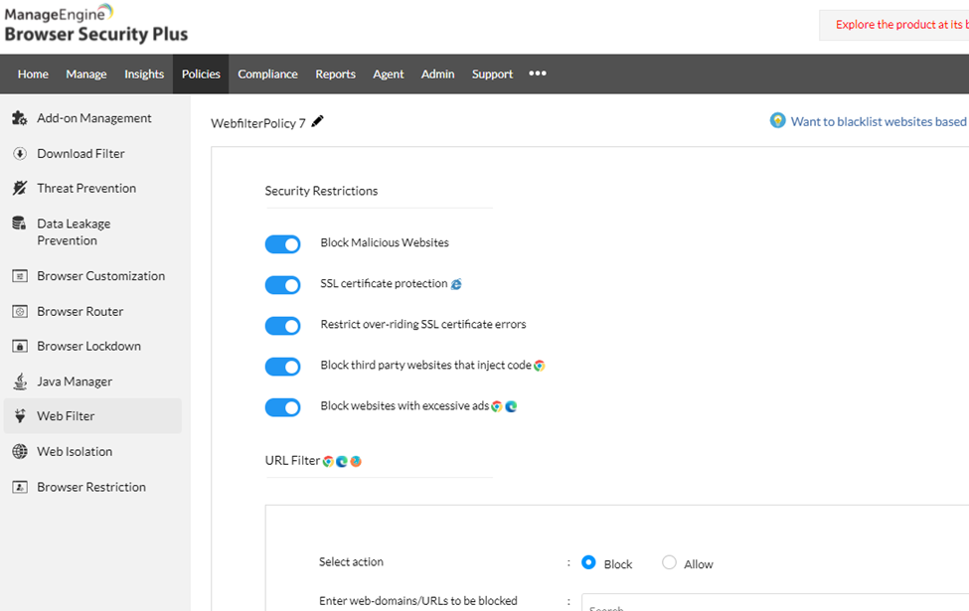

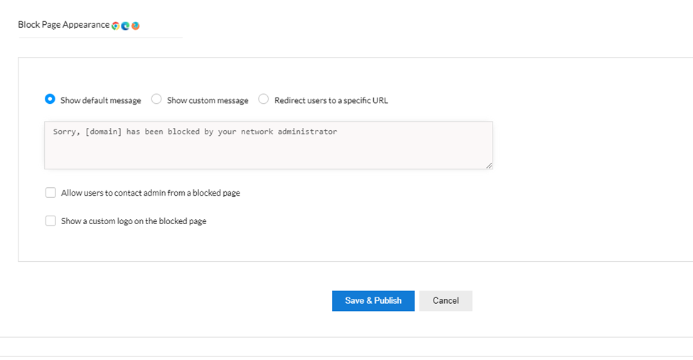

### Testing

1. Using Web Filtering, enter in the name of a URL you wish to block. You may also customize how the page will appear when someone attempts to go to that URL. At the bottom of the page select Save and Publish.

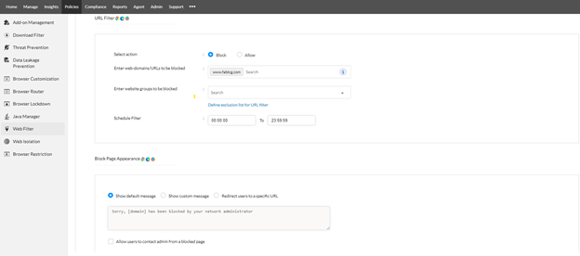

1. Now you will find the website you are wanting to filter put into a list. We currently have one website. Select the three dots at the end of the rule and then select deploy to group.

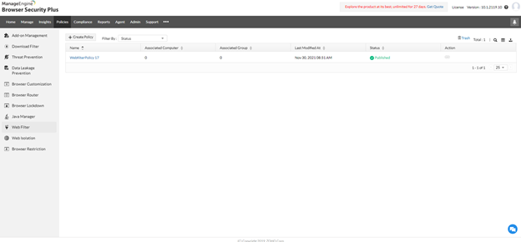

1. Select the group you wish to deploy the Filter too. Then Select Deploy.

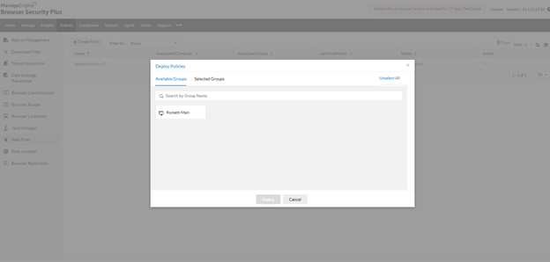

1. When you attempt to go to that UR, you will be given the message as shown below.

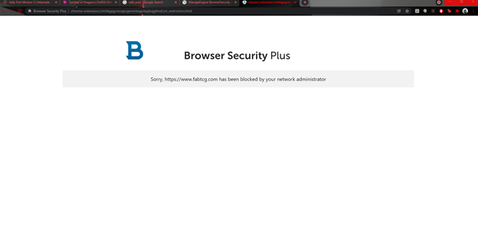

## Recommendations (Luis)

Our team identified ManageEngine’s Browser Security Plus Free as an alternative enterprise browser manager. This tool is used for maintaining an admin’s visibility and control over an organization’s web browser and it’s plugins. It allows for great security features such as Web Activity Trafficking, restricting access to certain websites, blocking downloads, but it also helps enforce security configurations.   
 It is thus imperative that the IT team configures new security configurations correctly and does not allow for the default settings and that configurations are always relevant. Users may be able to visit new untrustworthy sites and thus regular monitoring is necessary as well as quarantining computers that have visited and/or downloaded from untrustworthy sites. Additionally, it is the responsibility of the IT administrators to ensure that all computers are compliant with company standards and that certain features like Google Sync are disabled, passwords are not saved and that cookies are not granted permissions. The best way to ensure universal compliance is to train users and enact policies and ensure their understanding. More features and how to enforce them can be accessed on <https://www.manageengine.com/browser-security/what-is-browser-security-plus.html>**.**

## Alternatives (Kari)

Our team identified ManageEngine’s Browser Security Plus Professional as an alternative enterprise browser manager. This tool is used for maintaining an admin’s visibility and control over an organization’s web browser and it’s plugins. It allows an organization to view all of the browsers on a network, understand which are default browsers, and view all the add-ons. An organization can also control which websites a browser can visit, which plugins can be used, mass distribute extensions, and will isolate suspicious browser sessions to protect the network. Another benefit to this browser manager is that it helps monitor compliance. The tool comes with compliance policies built in and an administrator can build custom ones. If a computer is violating these compliance policies an administrator will be notified with instructions on how to ensure the computer meets compliance. This security tool is an effective way to protect a network from browser based cyber attacks. This tool has scaleable price options with coverage for 50 computers at $345 per year and a single user license. Additionally users can be added starting at $195 annually and training is available for purchase starting at $495 for web based and up to $3,995. We highly recommend this as an option once Ashburn’s frog emporium grows to a large scale operation.

# Grafana

## Information About Tool (Marcos)

Grafana is an open-source analytics and interactive visualization web tool that provides charts, graphs, and alerts for the web when connected to supported data sources. Grafana won’t require us to ingest data to a backend store or vendor database. This data visualization tool will instead unify our existing data coming from our event monitoring tool Prometheus. With Grafana alerting, we can create, manage, and silence all alerts within one interface. This allows Ashburn’s Frog Emporium to easily consolidate and centralize all our event alerts.

## Prerequisites (Marcos)

* The following platforms are supported by Grafana
* Debian/Ubuntu
* RPM-based Linux (CentOS, Fedora, OpenSuse, RedHat)
* macOS
* Windows 10
* Hardware Recommendations
  + Minimum recommended memory for Grafana: 255 MB Minimum recommended CPU: 1
* Supported Web Browsers
* Chrome/Chromium
* Firefox
* Safari
* Microsoft Edge
* There are three payment tiers that are associated with Grafana. These tiers are Free, Pro, and Advanced. The monthly cost of each tier as followed:
  + Free: $0.00
* 50 GB of Logs
* 50 GB of traces
* 14 days retention for metrics, logs, and traces
* Access for up to 3 team members
  + Pro: $49 (Per Month + usage)
* 100 GB of Logs
* 100 GB of traces
* 13 months retention for metrics
* 30 days retention for logs and traces
* Access for up to 10 team members
  + Advanced: Custom (Tailored for teams and enterprises with large sets of metrics and many tools)
* Custom volume, retention, and users
* Additional support and account services

## Instructions (Luis)

### Installation

1. Grafana is used as a data visualization tool which will allow us to combine it with Prometheus. Prometheus is already set up to monitor the network and alert us when there are anomalies but, we will be using Grafana to create a customizable dashboard which will show us the data capture by using graphs in real time. To do this, we will also configure Prometheus to launch as a service so that network traffic can be monitored the moment the machine is turned on. To do this, we will first travel to <https://grafana.com/grafana/download?platform=windows> to download the latest version which for us is Grafana 8.2.3. We will be doing customization with node exporter which may not be necessary or work with previous or later versions of Grafana. 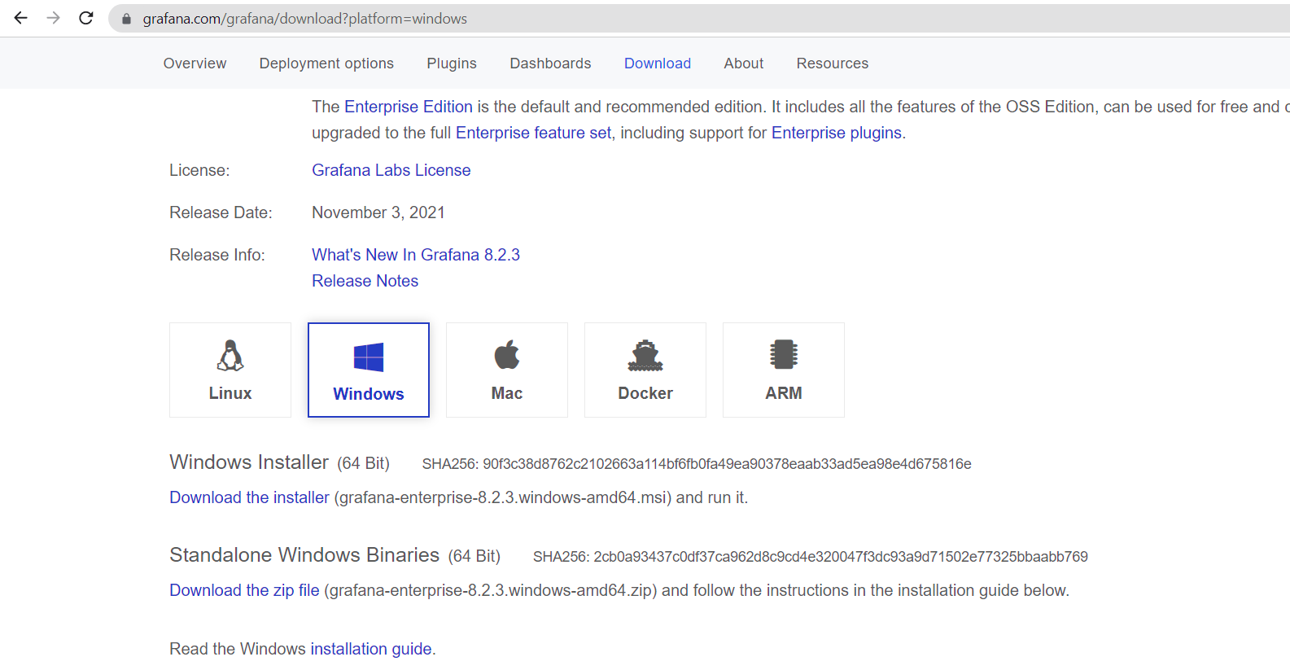
2. An MSI file should download, click it once it has downloaded.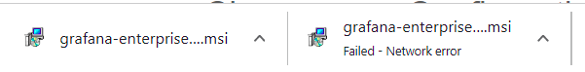
3. Check the application that Defender has prevented and click “Run Anyway”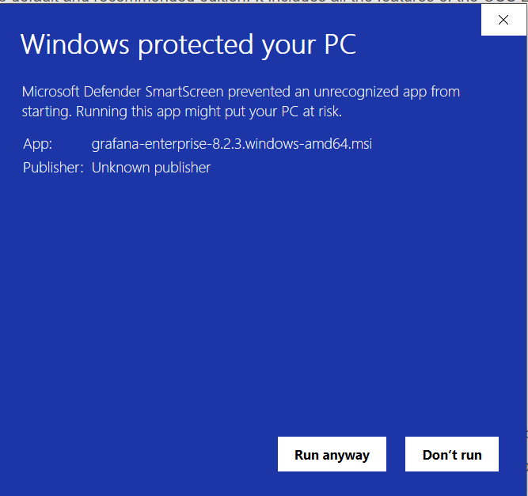
4. Click “Next”

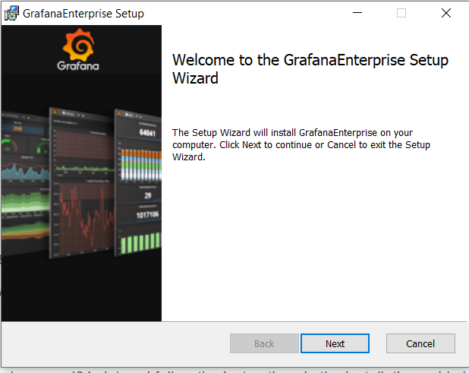

1. Read the End-User License Agreement and click “Next”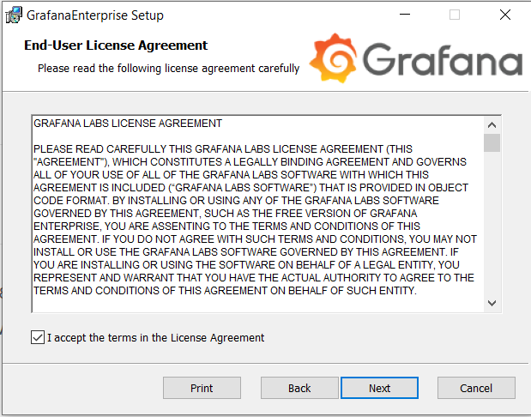
2. We will be changing the location, we will click “Browse” then create a new folder called “Monitoring”, we will be saving Grafana to a “Monitoring” Folder. Click “Next”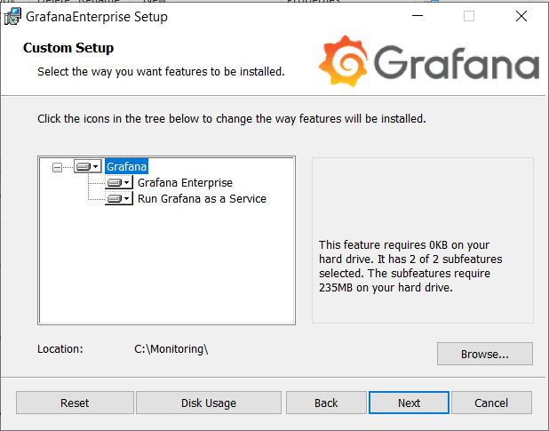
3. Click “Finish”

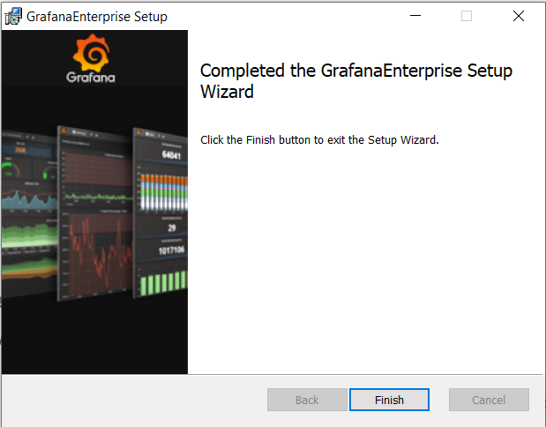

1. Due to our previous installation of “Zone Alarm” we will be presented with a prompt letting us know that grafana-server.exe is trying to access the internet. Click “Remember this setting” and then “Allow”

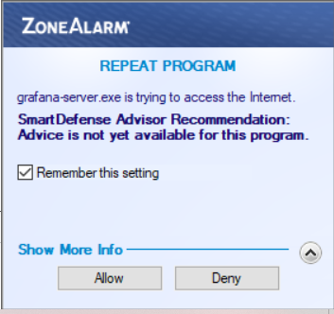

1. We will now change the default configurations of Grafana, we will go to the “Monitoring” folder, into the “grafana” folder then we will open the “defaults” with Notepad.

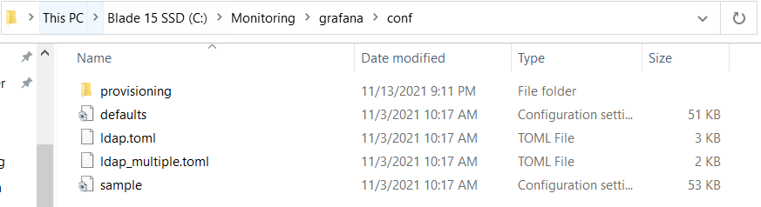

1. We will enable SMTP and emailing of alerts by going to “SMTP / Emailing” section and changing the “Enabled” under [smtp] to “True”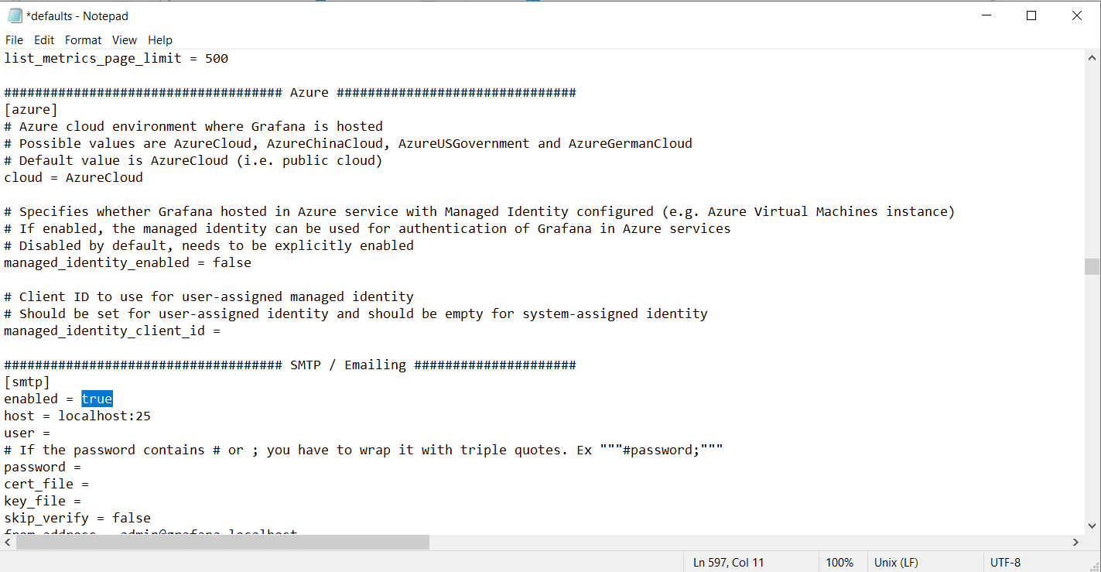
2. Open up Chrome Browser and in the search bar enter “localhost:3000/login”. We will be able to monitor our network through a portal on our browser, so we must first make an administrator account that will allow us to do so.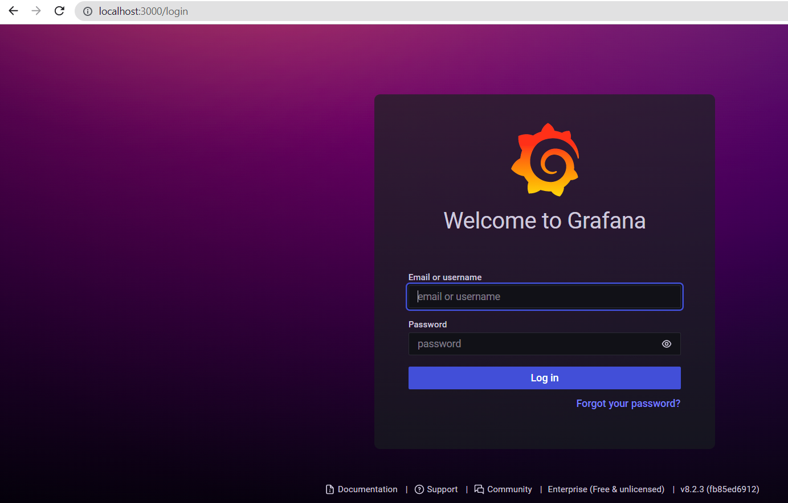
3. For now, enter “admin” as the username and “admin” as the password.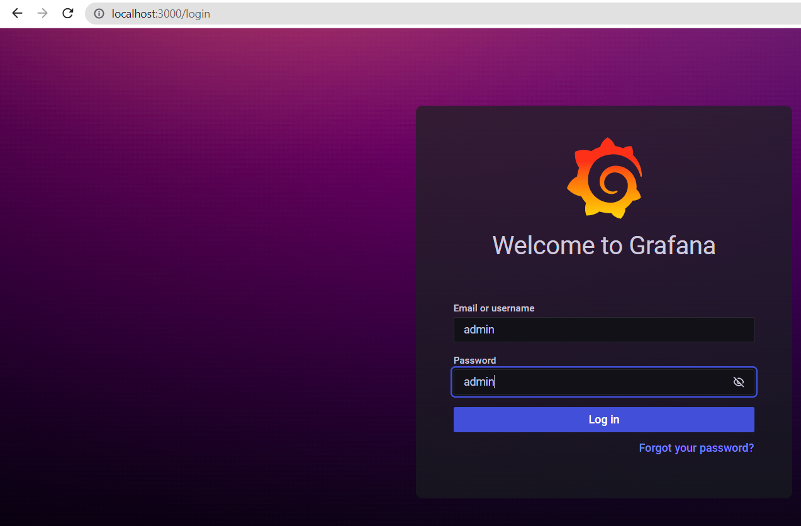
4. You will be asked to enter a new password, create a secure new password with letters, numbers, symbols and make it at least 10 characters long. 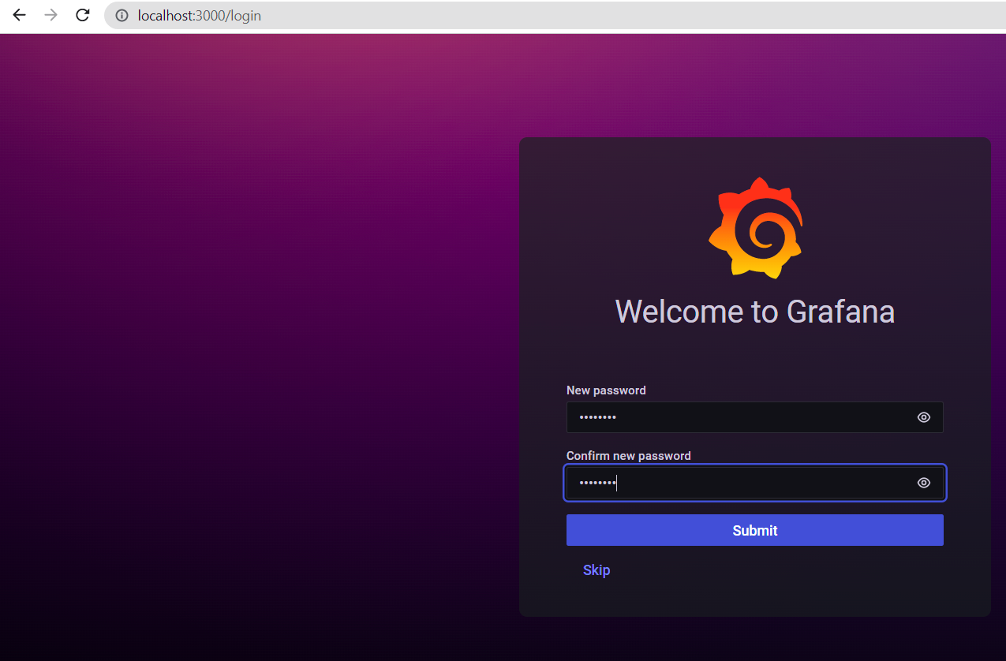
5. Now we will be directed to Grafana’s home screen. 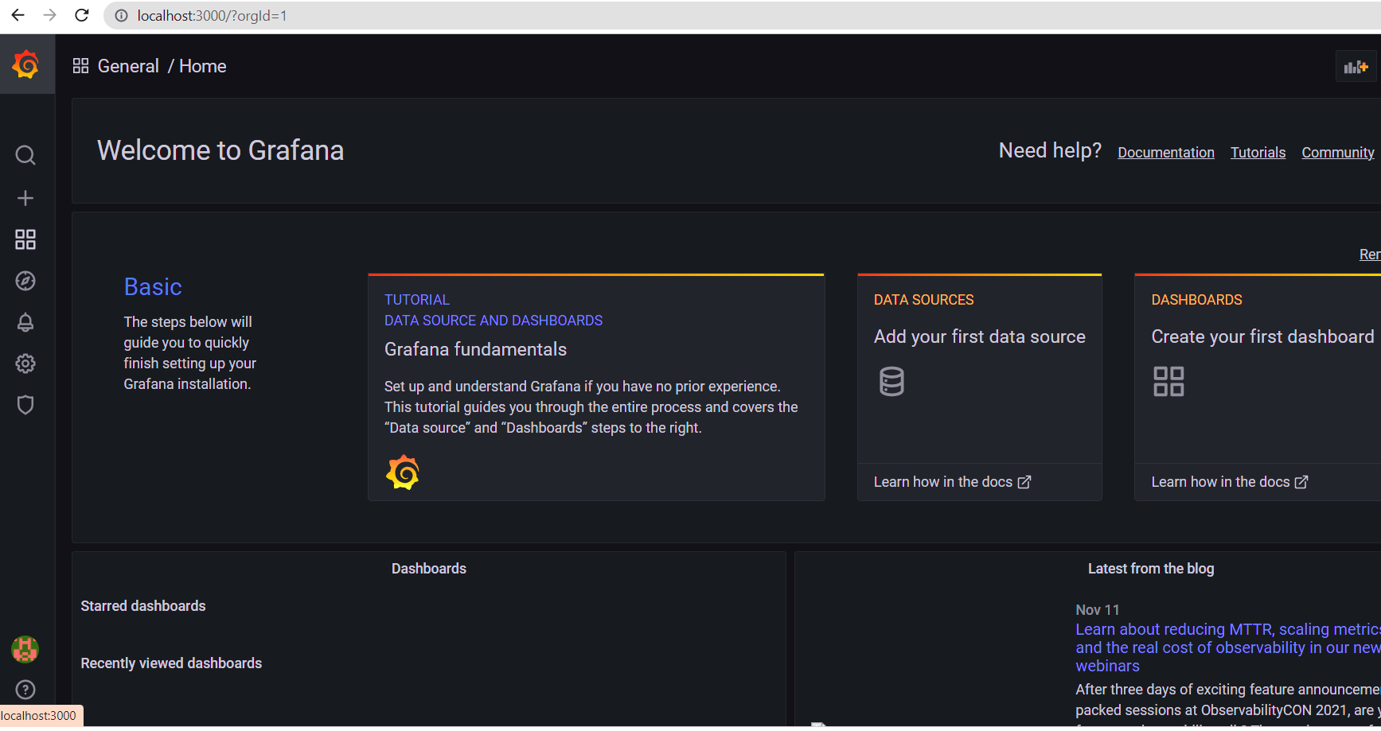
6. Click on the gear wheel icon on the left tabs and you will be directed to the Configuration screen. Click on the “Add data source” 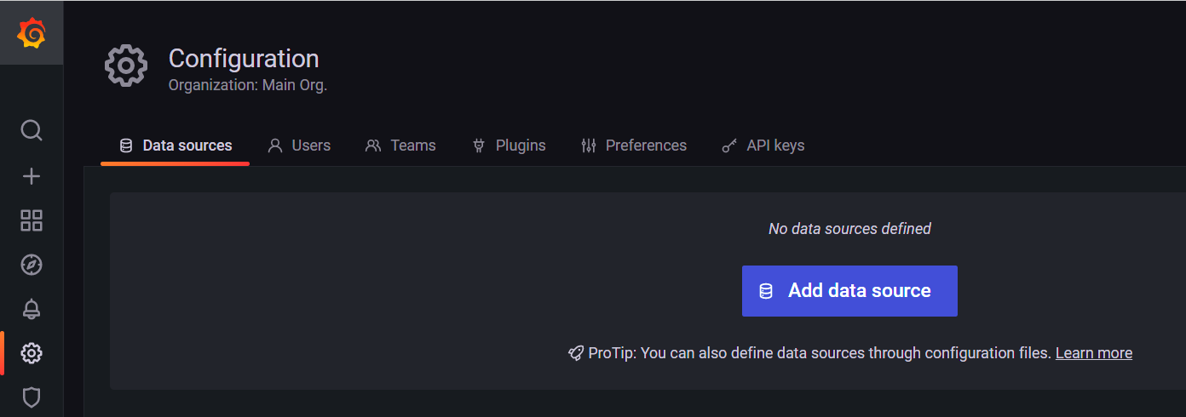
7. Click on the prometheus option then “Select” 
8. In the “URL” section type in “Localhost:9090”, this is the port location of Prometheus, scroll down and click on “Save and Test”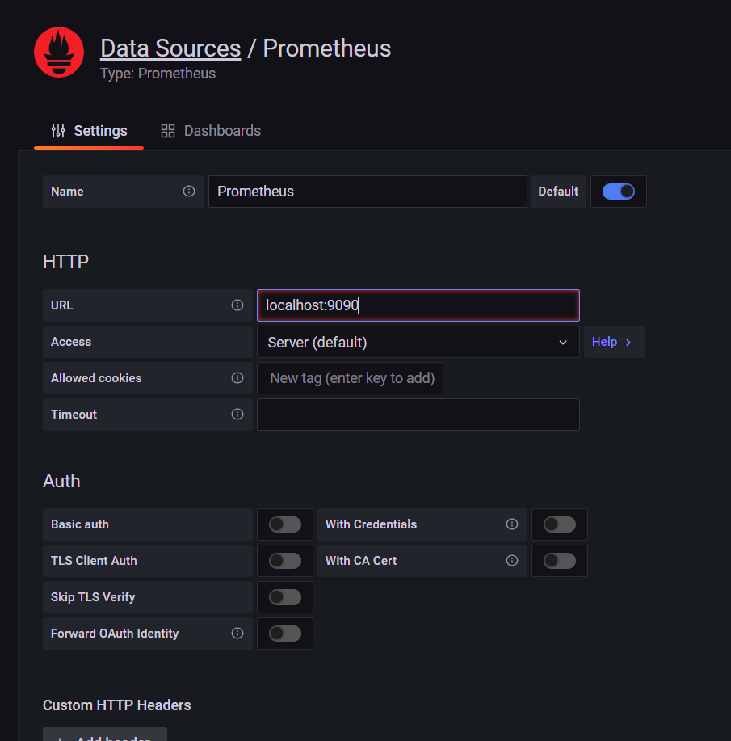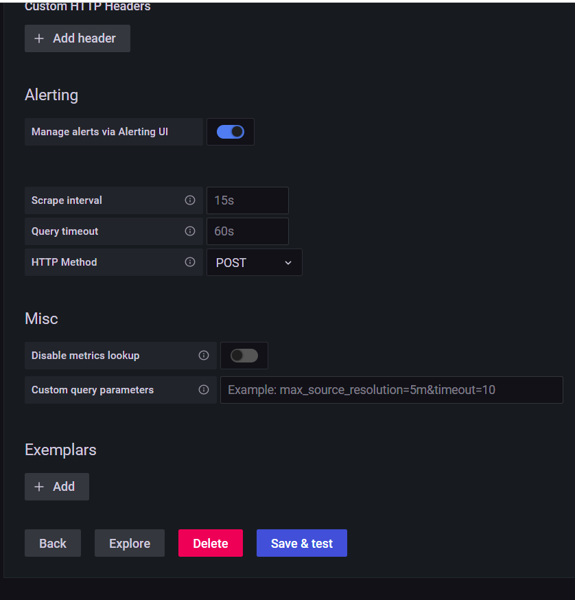
9. If it is configured correctly, then it will say “Data source is working” now scroll back up and change the name to “Ashburn-Frog-Emporium”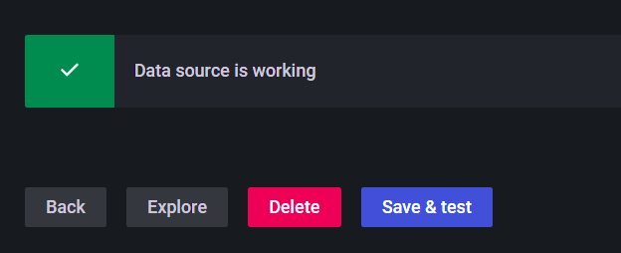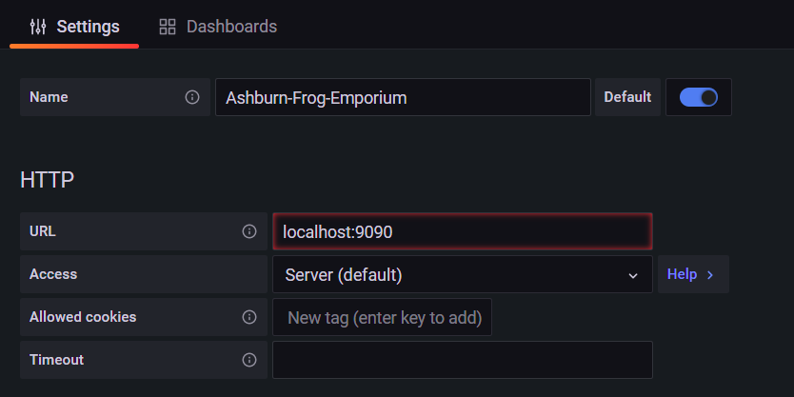
10. If you go to <http://localhost:3000/datasources> you will now see the datasource we just created as “Ashburn-Frog-Emporium”. 
11. Now we need to download a preconfigured Windows Node as our dashboard. Go to grafana.com/grafana/dashboards/2129 click on the “Download JSON and it will download “Revision 3”. Save the file “windows-node_rev3” to the “Monitoring Folder” we previously created.

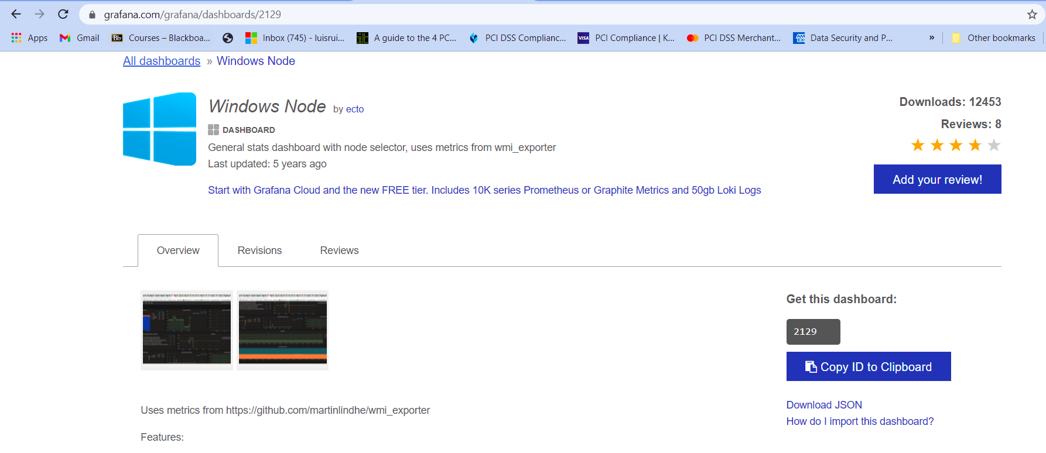

1. Open the folder, we will now need to make configurations to make it work on Grafana. We will use the “Control-F” to find the word “wmi” and change it to “windows”. The reason being is if we leave it as “wmi-exporter” then no data will be shown on Grafana since the “wmi-exporter” has become unused due to recent revisions. 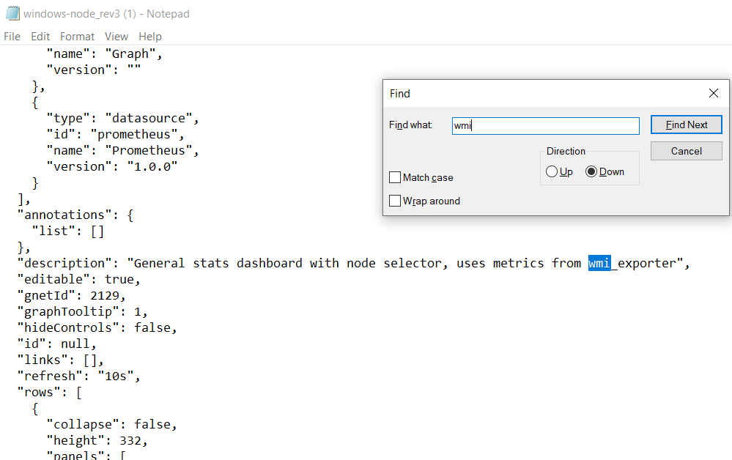
2. Change all instances of “wmi-exporter” to “windows-exporter” 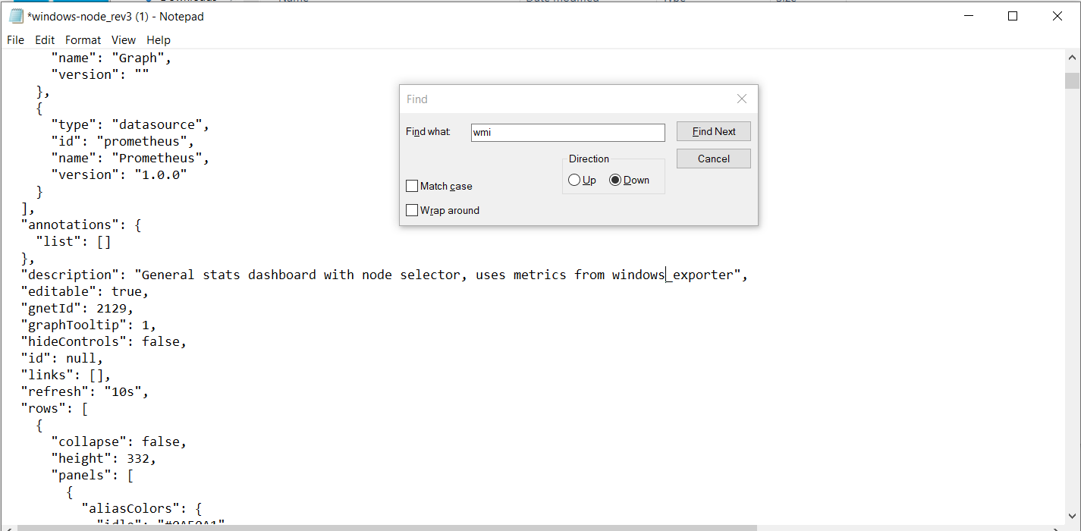
3. Once Notepad cannot find “wmi” then revise the file to make sure that everything has been changed to “windows-exporter”. 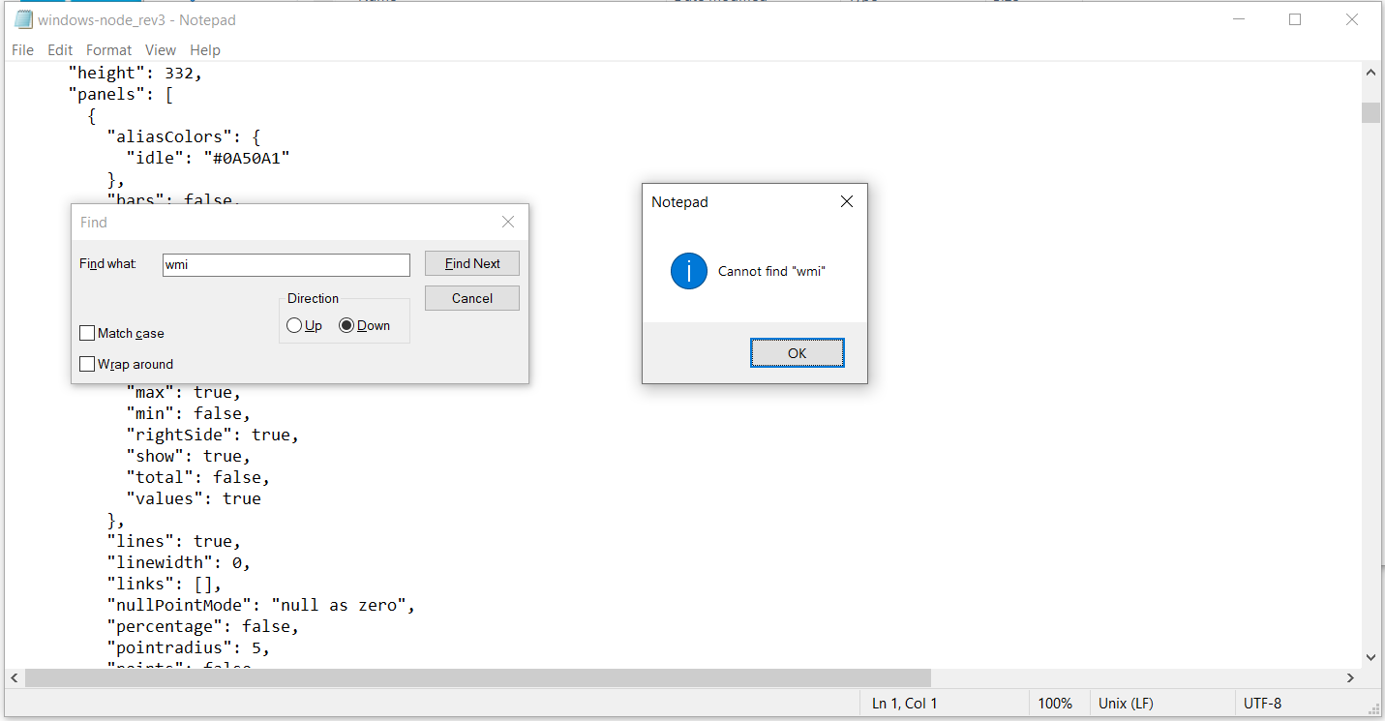
4. Go to “localhost:9090/targets”. In the second installation guide, localhost 9182 was added as a target in the Prometheus File. We are checking to make sure that both targets are up and running, if “localhost:9182” is not showing up then refer to the second installation guide. That localhost will allow us to monitor our performance. 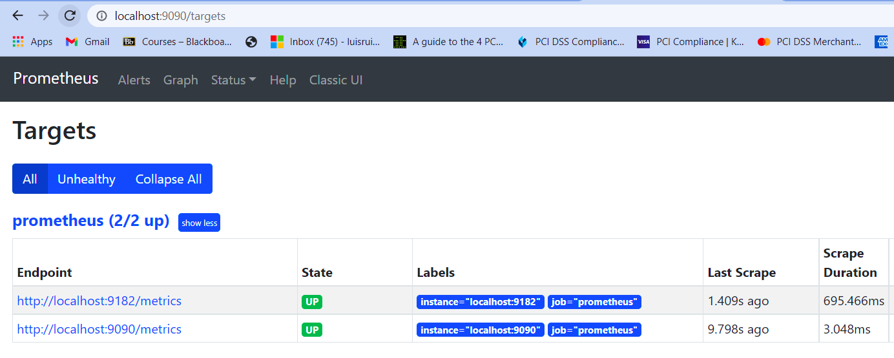
5. Go to “localhost:3000/dashboard/import” and click on “Upload JSON file” and choose the windows node file that we just configured.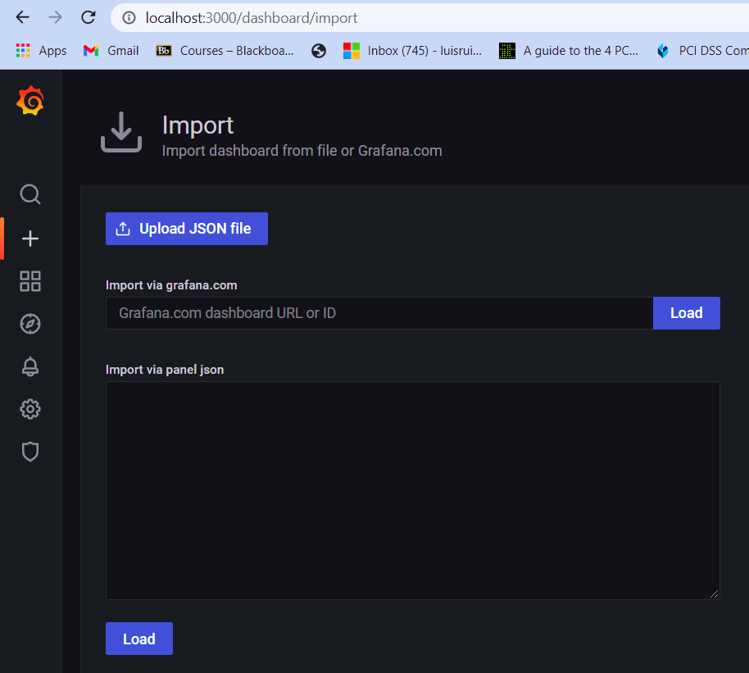
6. Name it as “Windows Node” and make sure the correct prometheus file is chosen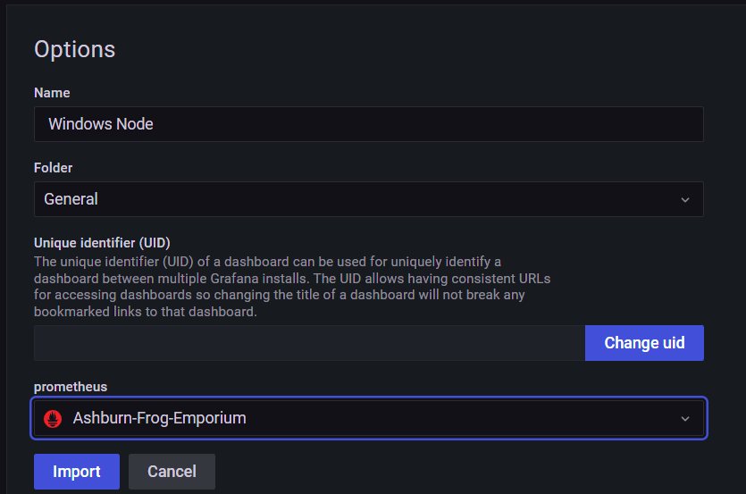
7. If it has been successfully uploaded then the graphs should be populated with data, however, if it has not, then it will show “No data” on all the graphs. One of the most common problems is that the “JSON” file was not configured correctly or that “localhost:9182” is not running properly or is a target.

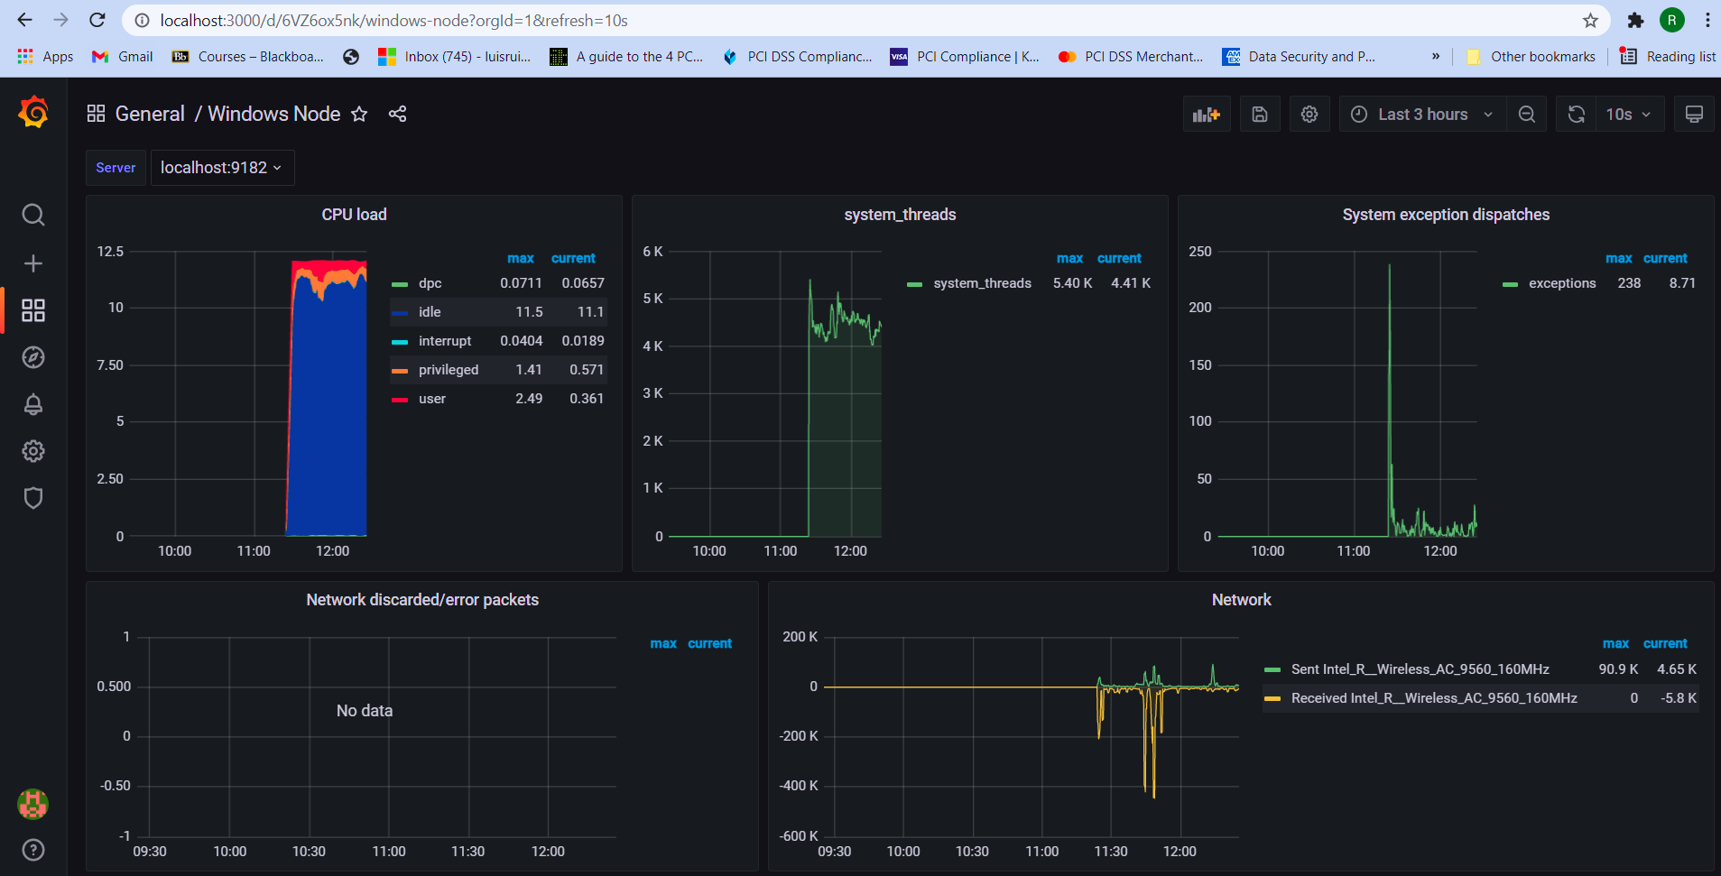

### Configuration

1. In our original installation of Prometheus, we did not install it as a service but as executable. We now want to change it as a service and have it launch during startup so that Prometheus can start monitoring as soon as the computer is turned on and have that data recorded by Grafana. NSSM, the Non-Sucking Service Manager will allow us to install our version as Prometheus as a service. Go to nssm.cc/download. We are downloading nssm-2.24

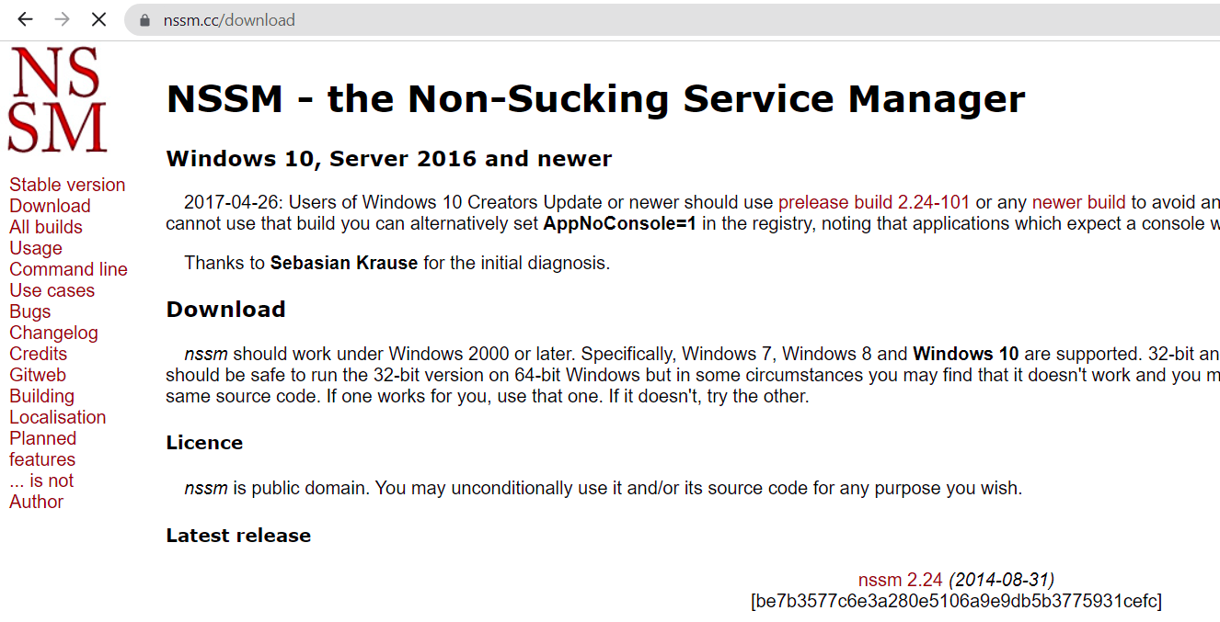

1. The folder will download as a zip file. It should be scanned by Zone Alarm but scan it for viruses manually just to be sure.****
2. Once the file has been determined to be clean, extract the folder to the “Monitoring” folder.

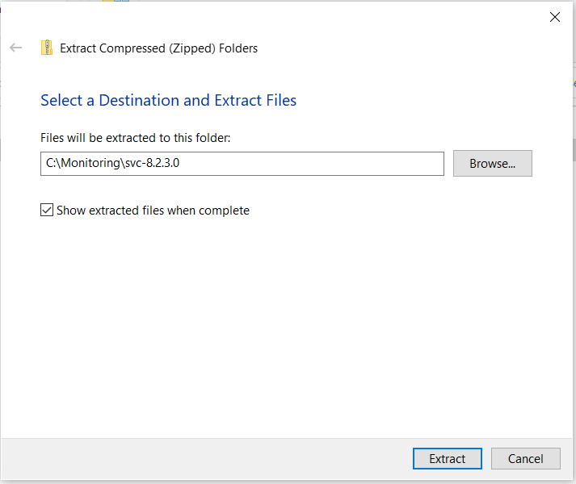

1. If we click on the “NSSM” application we will be shown the commands. 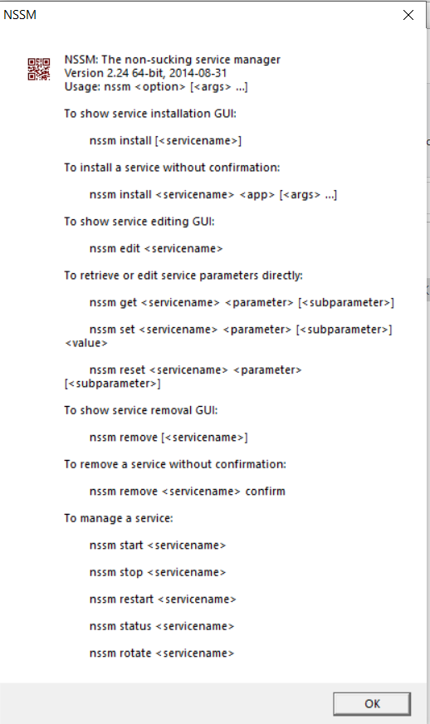
2. We will need to open powershell using administrator privileges.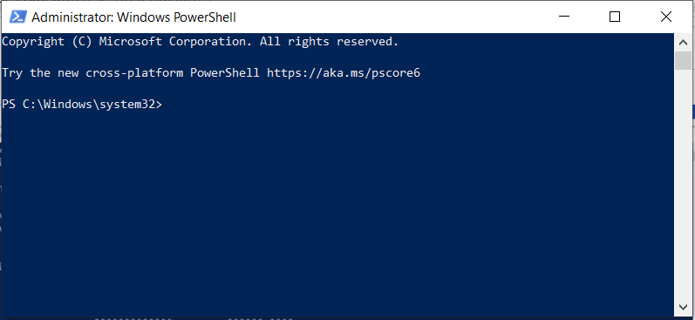
3. Type “cd” then the location of the NSSM folder. Type “dir” to show the directory, make sure the nssm.exe file is present. Then type in “.\nssm.exe install prometheus”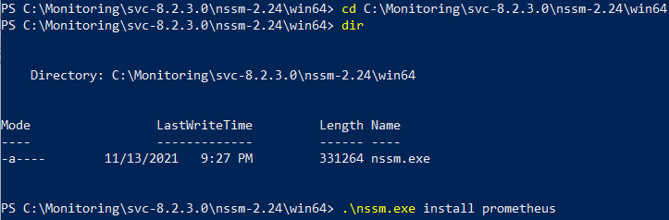
4. Now you will be shown the following prompt. Since we moved to the Monitoring folder directory before installing it as a service you will not have to make any changes except to create the service name. Just enter “prometheus” and then click on “Install Service”. 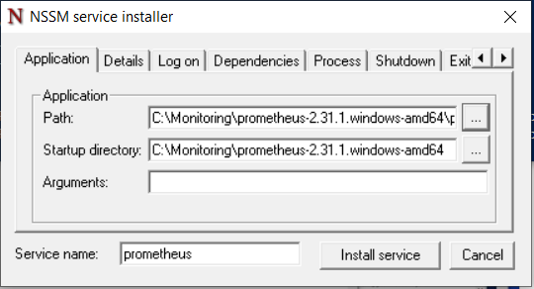
5. Click “Okay” once you see that it was successfully installed as a service. While it is not necessary to install prometheus as a service to get this working, we did configure it as such so that Grafana will immediately begin logging when the computer is not shut down..

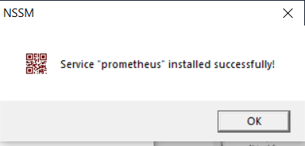

### Testing

1. On default, Grafana will only record the last 5 minutes of network performance and packet loss. We will open grafana and check our computer CPU and from what we are noticing now, is that there seems to be a high strain on CPU load and we can also see that there was a download recently on the network due to the received packets. There are no Network discarded/error packets recorded on our system as of yet so no data has been shown, that is great! Now, we will leave it as it is for now and come back in a week. 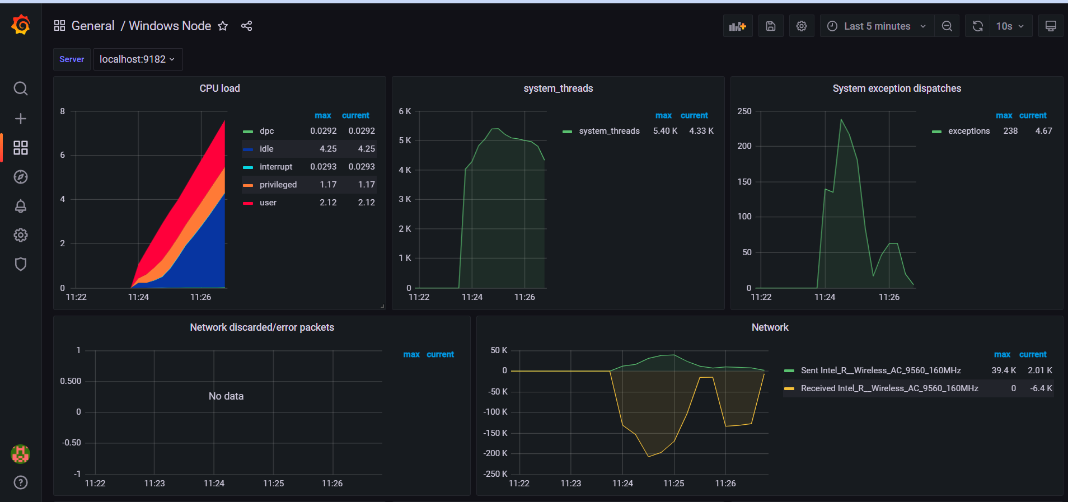
2. After a week, when we log in, we will see that there was a performance error again. We also updated one of our apps upon login and that is seen on our network graph. 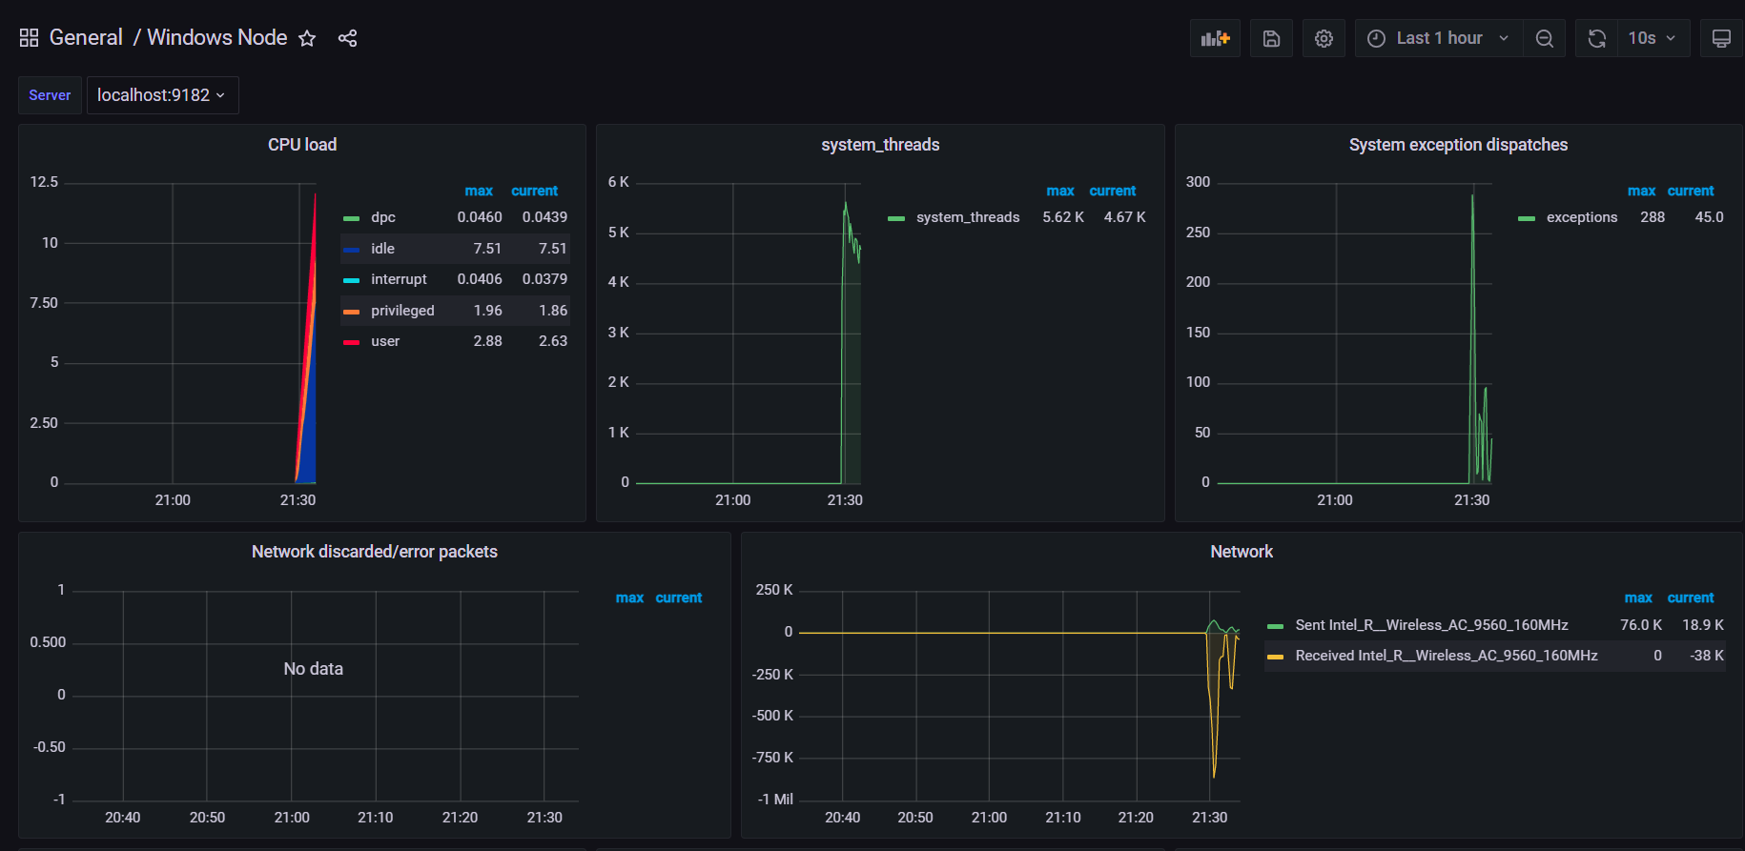
3. Let’s change the history range from 1 hour to 7 days. We will do this by clicking on the clock icon in the top right corner. 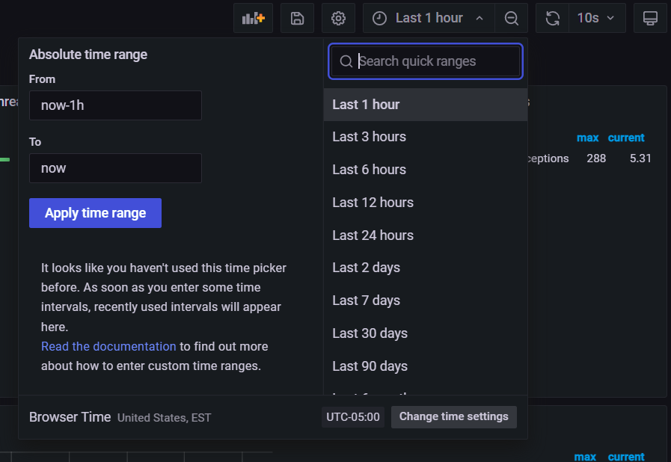
4. We will now notice that there was a large download done recently. Let’s investigate this further since it shows it was done recently. 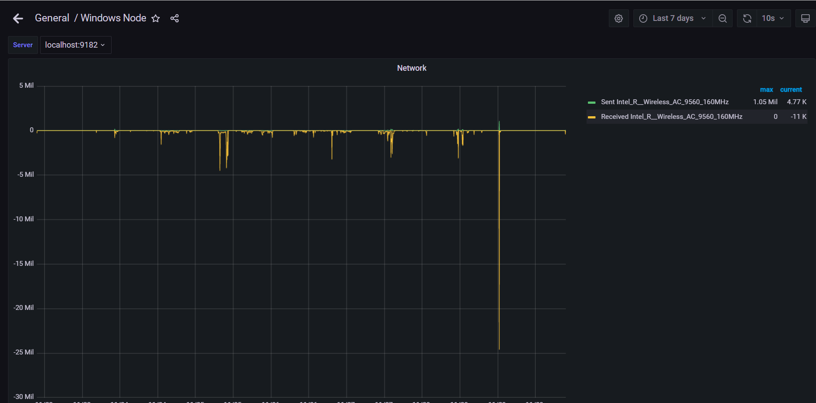
5. One thing that we will notice is that while the download occurred today it was done very late. We can now select from sent packets and receive lets see how much was sent by selecting sent. This was within range however the time is still a red flag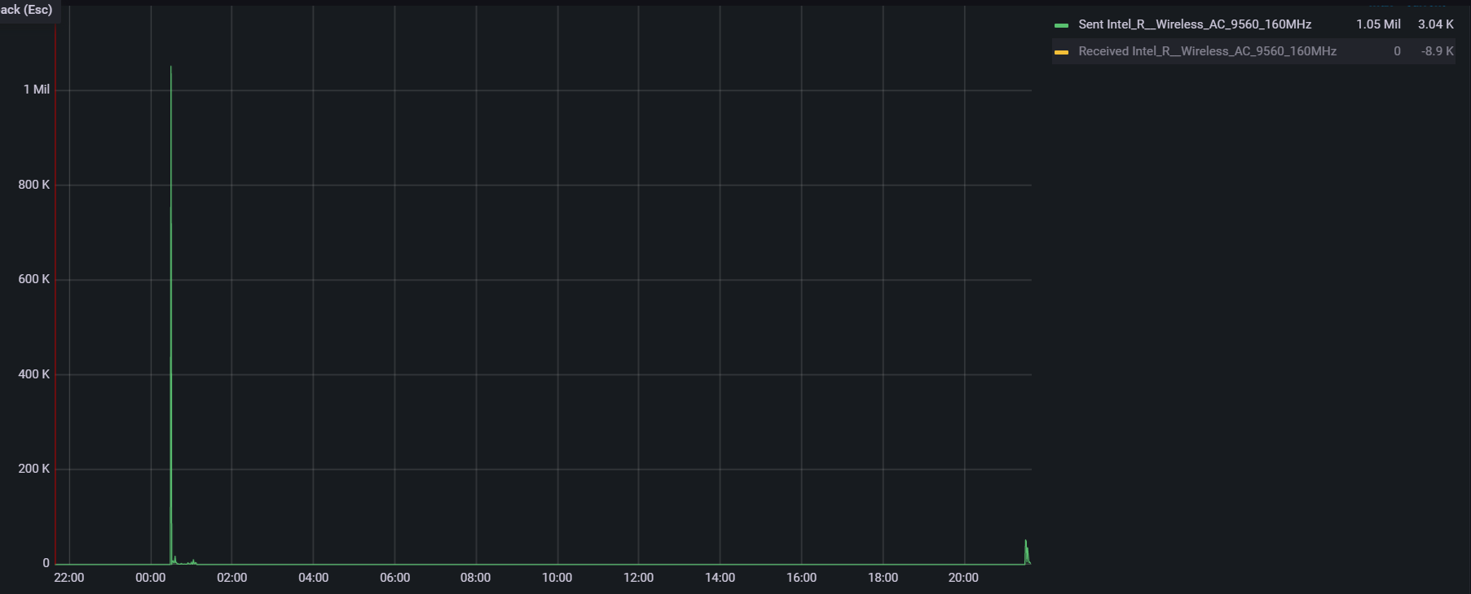
6. Now we will check the received packets. Wow! There was just a huge download that occurred at 12:30 in the morning! You can see the time on the bottom part of the graph. This is suspicious behavior that we need to investigate but before that let’s also check our system performance!

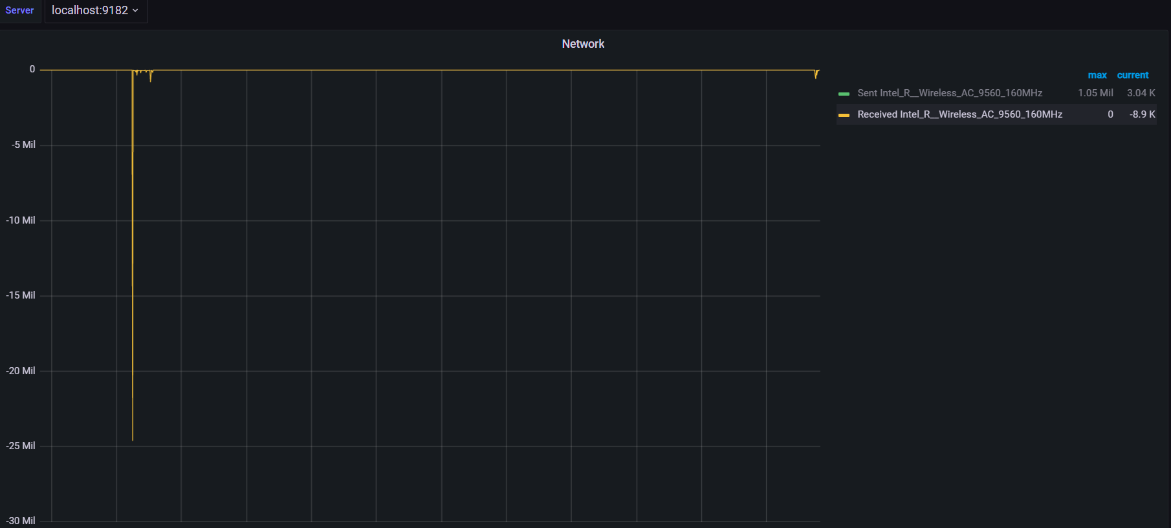

1. Let's go back to the dashboard home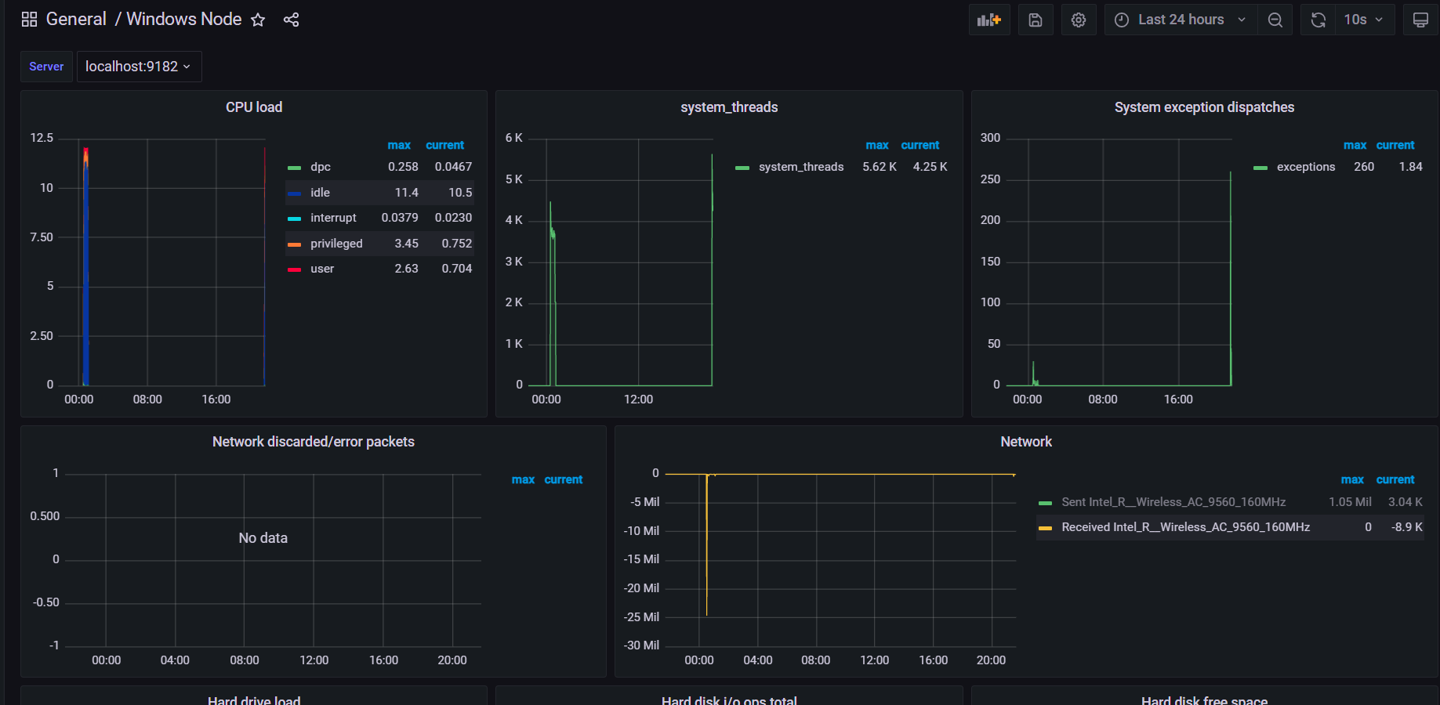
2. Let's choose CPU, we can now see the computer was turned on for a short while during the night and not for long. It seems that someone gained access to the computer, logged in and downloaded files during the middle of the night! This was easy to investigate and now we will use our other tools such as snort and prometheus logs to sniff for suspicious activity and flags. This is not regular behavior and we need to find the user whether it was an intruder or employee and take the proper measures such as legal or workplace dismissal depending on what occured.  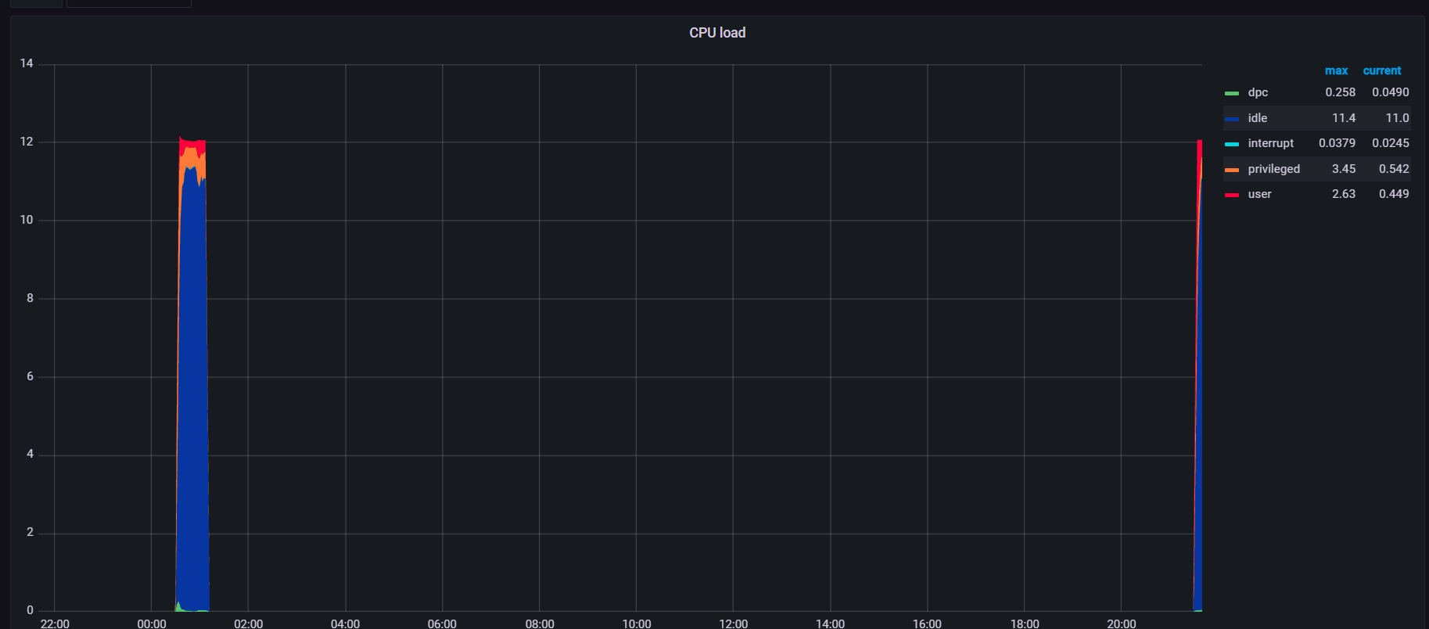

**Recommendations (Kari)**

Grafana is an effective tool that improves the visibility of Prometheus’ data. It is important to ensure that the tool is kept up to date, the user understands how to use the tool, and troubleshooting is available. On the Grafana website there are resources available for learning more about the tool and how to use it.

The user should review the videos and webinars relevant to their tool to ensure they understand how the tool can be used and managed. Additionally this will help the user understand when patches might need to be deployed. The following URL will bring the user to the videos designed to help the stay informed: <https://grafana.com/videos/>

As a user is getting to know the tool, the Grafana website provides tutorials to the user. We recommend reviewing those when troubleshooting or attempting something new with the application. The following URLs have how how to guides and more: <https://grafana.com/tutorials/> and <https://grafana.com/docs/>

Additionally, it is important to keep the prometheus files well organised and backed up so when you need to access them at a later date they can be easily accessed.

## Alternatives (Ryan)

An alternative to Grafana is Datadog. Datadog is a monitoring and security platform. Datadog is capable of monitoring databases, users, networks, and security policies; all with their own visualization flows similar to Grafana. For Network Monitoring with Visualization, Datadog would install an Agent that would be the SNMP Manager. This would then be able to queries SNMP Agents that are preloaded on all network devices. This allows you to also create a map of your network. To add an SNMP Agent to the SNMP Manager, there are a few different ways in which one can do that. One of which would be by scanning the network or a range or IP addresses. Another is by collecting the MIBs or Management Information Base for each of the objects you wish to monitor and input them one at a time. Finally, you are able to use OIDs or Object Identifiers in order to monitor specific metrics for your SNMP devices. Datadog would then be able to create visualizations of the metrics monitored.

Datadog then gives you two different kinds of network monitoring to choose from and list their prices as though your organization pays for the service for an entire year. To be able to analyze and create visualizations of the traffic that is flowing through the network, you would pay five dollars per month per server for a total of sixty dollars a year per server. If you wish to dig deeper into each SNMP enabled device, such as seeing the interface bandwidth and disk utilization, the organization would pay seven dollars per month per device that was going to be monitored for a total of eighty five dollars a year per device.

# Conclusion (Luis)

Ashburn’s Frog Emporium reached out to our security team to install security tools to protect users and install a visualization tool to help their system’s administrators protect the network and conduct analysis for suspicious activity. Our team has identified Duo Mobile, Enterprise Browser Management and Grafana to be used to meet their demands. These tools will provide user security through Two Factor Authentication, Browser Hardening and Visualization for Prometheus logs, respectively. Duo Mobile is free for up to 10 users and will also provide security to the mobile device as well as security back ups. Alternatively to this we will use ESET Secure Authentication which is a paid service by the ESET company and will also provide offline authentication through hardware tokens, IP whitelisting, and auditing solutions. Our browser hardening tool is Enterprise Browser Management which will detect, enforce, control and audit the network through browser configurations, the tool is free for up to 25 users. Our team found this app as an incredible tool to use to harden the network so our alternate suggestion would be to pay for the Professional version to take advantage of it’s robust tools especially to prevent browser cyber attacks. Lastly, Grafana is a free tool that pairs well with Prometheus and will visualize data based on user created graphs and configurations. This tool is harder to use and requires coding knowledge. If the administrators can not configure new graphs then we would suggest datadog which will come with preconfigured metrics to monitor the network. With these tools, we will be able to protect our users from weak passwords and browser attacks and we will be able to increase the efficiency of the administrator’s ability to monitor the network.

# References

ManageEngine. (n.d.). *Browser management for enterprises*. Enterprise browser management | Browser Management Software. Retrieved November 29, 2021, from https://www.manageengine.com/browser-security/browser-management.html

ManageEngine, communications@manageengine.com. (n.d.). *User Guide | ManageEngine Browser Security Plus*. Copyright (c) 2021 Zoho Corp. All Rights Reserved. https://www.manageengine.com/browser-security/help/

*Network Device Monitoring*. (n.d.). Datadog Infrastructure and Application Monitoring. https://docs.datadoghq.com/network_monitoring/devices/

Crozdesk. (n.d.). *ManageEngine Browser Security Plus | Software Reviews & Alternatives*. Crozdesk.Com. https://crozdesk.com/software/manageengine-browser-security-plus

*Duo Mobile App*. (2017). Duo Security. https://duo.com/product/multi-factor-authentication-mfa/duo-mobile-app

*Enterprise Browser Management | Browser Management Software*. (2021). ManageEngine. https://www.manageengine.com/browser-security/browser-management.html

*ManageEngine Browser Security Plus Reviews: Pricing & Software Features 2021*. (2021, March 4). Financesonline.Com. https://reviews.financesonline.com/p/manageengine-browser-security-plus/

*Mobile Device Security Made Easy with Duo’s Security Checkup*. (2017, October 17). Duo Security. https://duo.com/blog/mobile-device-security-made-easy-with-duos-security-checkup

*Pricing*. (2021). Duo Security. https://duo.com/editions-and-pricing

*Pricing - Grafana Cloud*. (2021). Grafana Labs. https://grafana.com/products/cloud/pricing/

*Requirements*. (2021). Grafana Labs. https://grafana.com/docs/grafana/latest/installation/requirements/

ManageEngine. (n.d.). *What is browser security plus?* ManageEngine Browser Security Plus | Overview, Features and Pricing. Retrieved November 30, 2021, from https://www.manageengine.com/browser-security/what-is-browser-security-plus.html.

ESET. (n.d.). *Overview*. Overview | ESET Secure Authentication | ESET Online Help. Retrieved November 30, 2021, from https://help.eset.com/esa/30/en-US/.